# I. Deliverable Package

| **No.** | **File** | **Notes** |
| --- | --- | --- |
| 1 | G6_SPM_DB_final.sql | Database, including both table structures and table data |
| 2 | G6_SPM_SRS_final.docx | Final SRS (Requirement) Document |
| 3 | G6_SPM_SDS_final.docx | Final SDS (Design) Document |
| 4 | G6_SPM_Final Product Backlog.xlsx | Final status for the application functions, which include:  - Function name, feature, roles, function description (changes compared to the original requirements are highlighted)  - In Charge, Planned iteration & Actual iteration  - Final status & note on the update you made  - The links to the SRS & SDS are tracked |
| 5 | G6_SPM_Issues Report.xlsx | Final issues tracking list of the whole project |
| 6 | G6_SPM_Final Release Document.docx | Final release document for, includes:  - Deliverable package list: DB script, SRS, SDS, Product backlog, Issue report  - Installation guides for user to install all requirements tools and apps for using  - User manual: include workflow for each roles in system |

Other related deliverables:

* Tagged source codes: https://gitlab.com/fu-kiennt-summer22/se1619-net-swp391/g6/-/tags/Final_Release
* Demonstration video: https://drive.google.com/file/d/13xAfrPX8v5AQQQ99sJ_gMvSKdvVyn6qu/view?usp=sharing

# II. Installation Guides

- Video tutorial to install Netbeans 8.2:

<https://www.youtube.com/watch?v=bC7yilM_wEw>

- Video tutorial to install MySQL Workbench:

<https://youtu.be/zvj4Dkr4xTA>

- Link to download the project:

<https://drive.google.com/file/d/1bHRJ7FLK4787a9Ao-E3kCRVTcOQ5Gl4c/view?usp=sharing>

- Video on how to run the project:

<https://www.youtube.com/watch?v=kWDZC0mOaWs>

- How to run project on Netbeans 8.2:

Step 1: We need to install Java SE Development Kit (JDK) before installing Netbeans IDE. First, go to the JDK download link above to download the JDK to your computer. You need to Accept the License Agreement first and then choose the appropriate installation for your system.

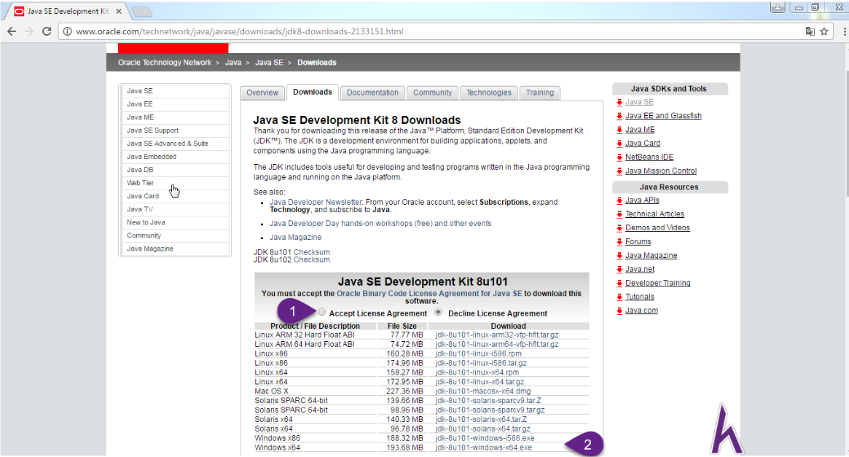

Step 2: Then you go to the Netbeans IDE download link above to download Netbeans to your computer. You need to Accept the License Agreement first and then choose the appropriate installation for your system.

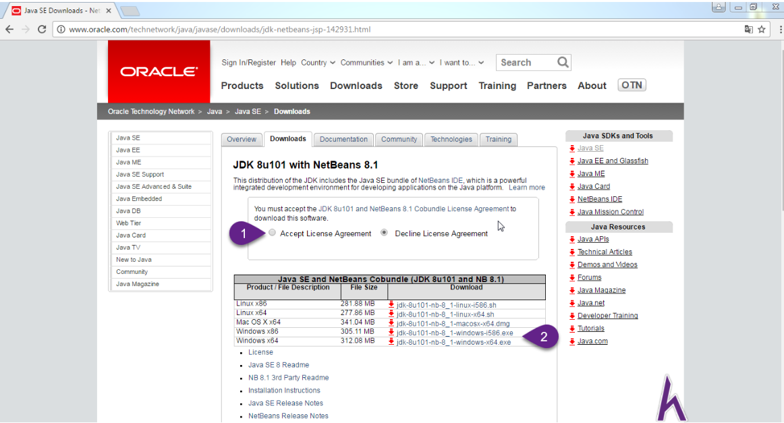

Step 3: After downloading JDK, launch Java SE Development Kit and click Next to continue.

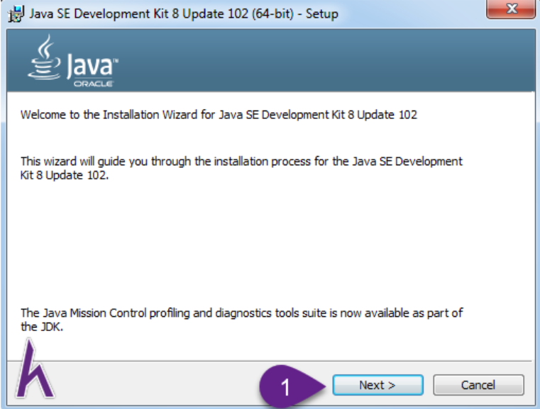

Step 4: Leave the defaults and click Next to continue.

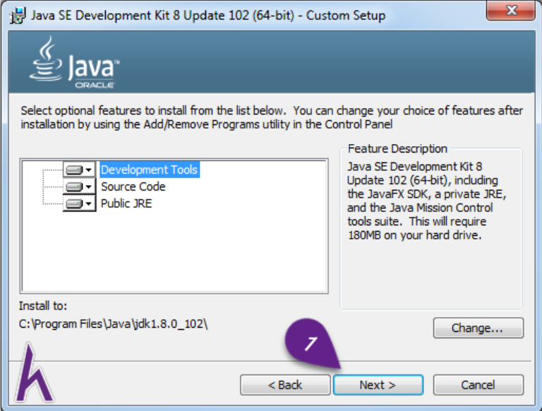

Step 5: The installation process appears, wait a little while to continue to the next step.

Step 6: You leave the default, click Next to continue.

Step 7: You wait for the installation process to take place.

Step 8: After the installation is complete, click Close to complete the JDK installation step.

Step 9: After downloading Netbeans IDE You launch Netbeans IDE to install click Customize to go to the next section or click Next to proceed to step 12.

Step 10 : You should select all the options then click OK to continue.

Step 11: You click Next to continue.

Step 12 : You select I accept the terms in the license agreement as shown, then click Next to continue.

Step 13 : Leave the default and click Next to continue.

Step 14: Leave the default and click Next to continue.

Step 15 : Leave the default click Next to continue.

Step 16 : You should select Check for Updates so that NetBeans is always updated to the latest version then click Install to install.

Step 17 : The installation process takes place, please wait.

Step 18 : Click Finish to finish the installation process.

Step 19: When the installation is complete, launch Netbeans IDE, if the interface appears as shown, you have succeeded.

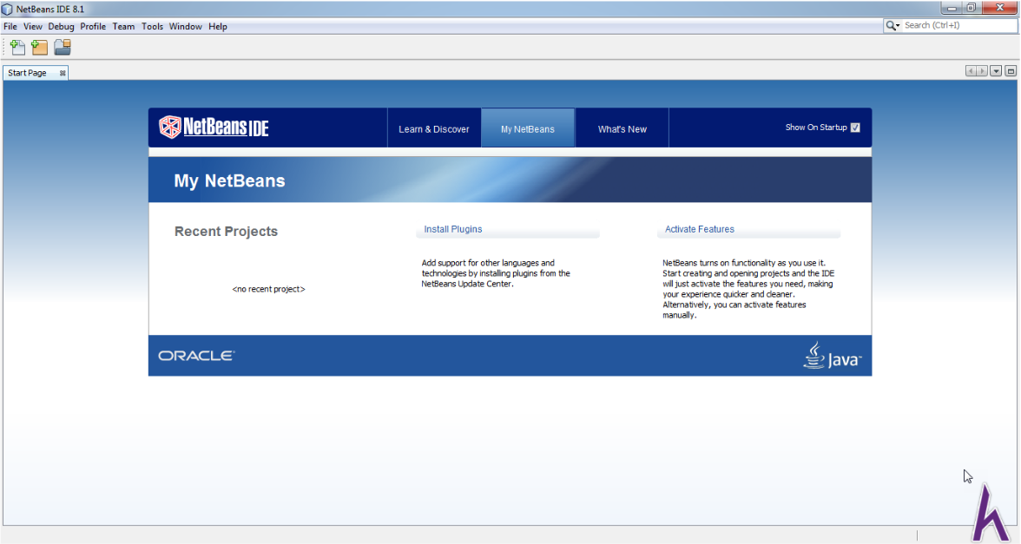

* How to run the project:

Step 1: click on the icon as shown in the picture to open the project

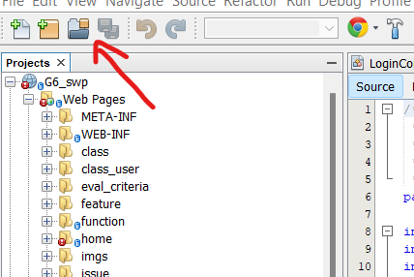

Step 2: select the downloaded project and press the open project button

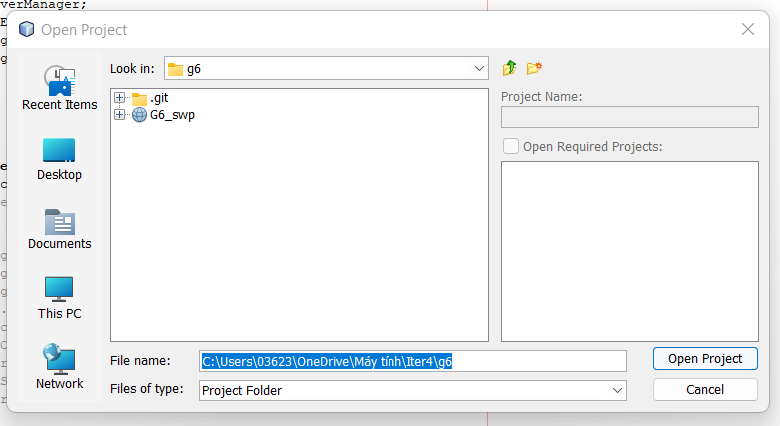

Step 3: in the project click on the DBContext.java file in the dal folder.

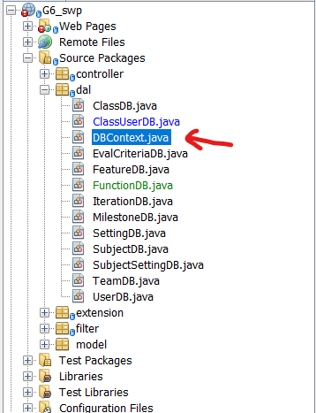

Step 4:

* Replace your mysql user with "root" on line 38.
* Change your mysql password to "0362351671" on line 39.
* Change your mysql url to "jdbc:mysql://localhost:3360/student_project_management" at line 40.

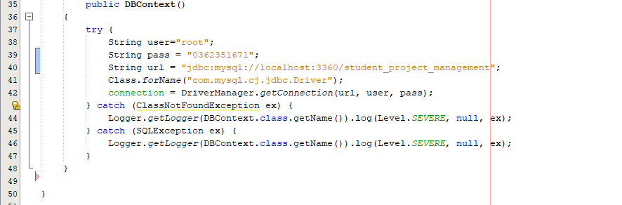

Step 4: Right-click HomeController.java in the controller folder => click Run File . So the project has run successfully

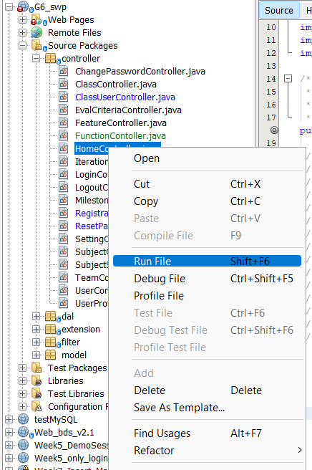

# III. User Manual

## 1. Overview

This web application – Student Project Management - provide an useful tool for project and subject control to teacher and student. Especially for FPT student who learn SWP391. With handy feature like Issue, Milestone and Tracking,…, this web promise to deliver first class Agile project management that rival Jira. As for FPT teacher (trainer) we base on SWP391 subject’s requirement to build up evaluation with precise and convenience.

## 2. Common

This workflow is for the General feature and is accessed by a role in the system call, User. In this workflow, as User you can view home page, can Register, login with your account, Reset and change password, User Profile and Dashboard access with each set role.

This is the Home page. Home page will show when you access to link: http://localhost:8080/G6_swp/home

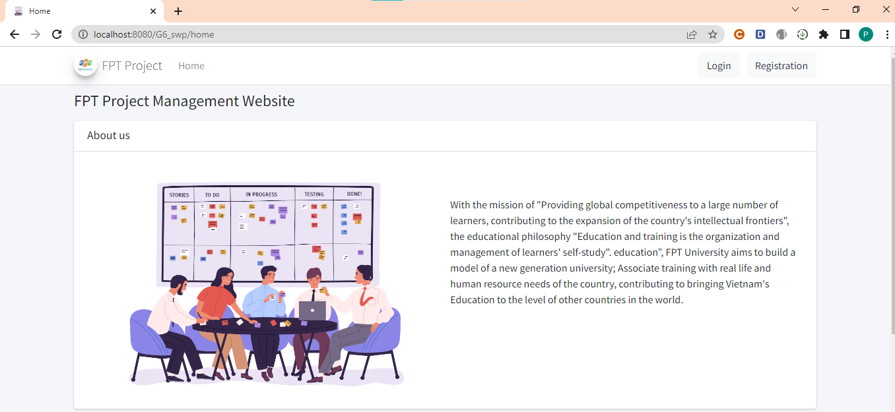

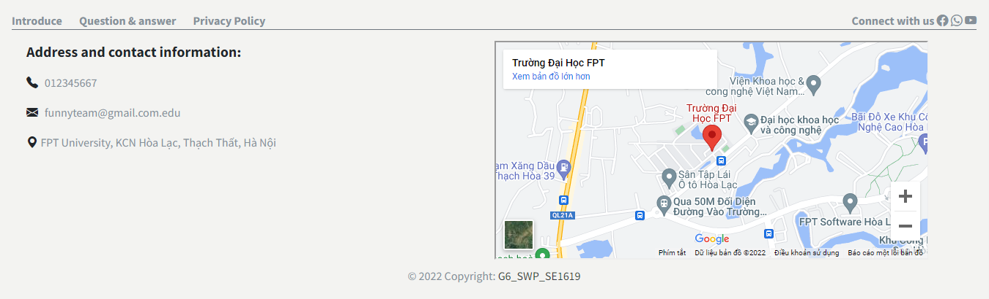

If you want to login in this system, you must register a new account. Enter your email and we will return your mail with password.

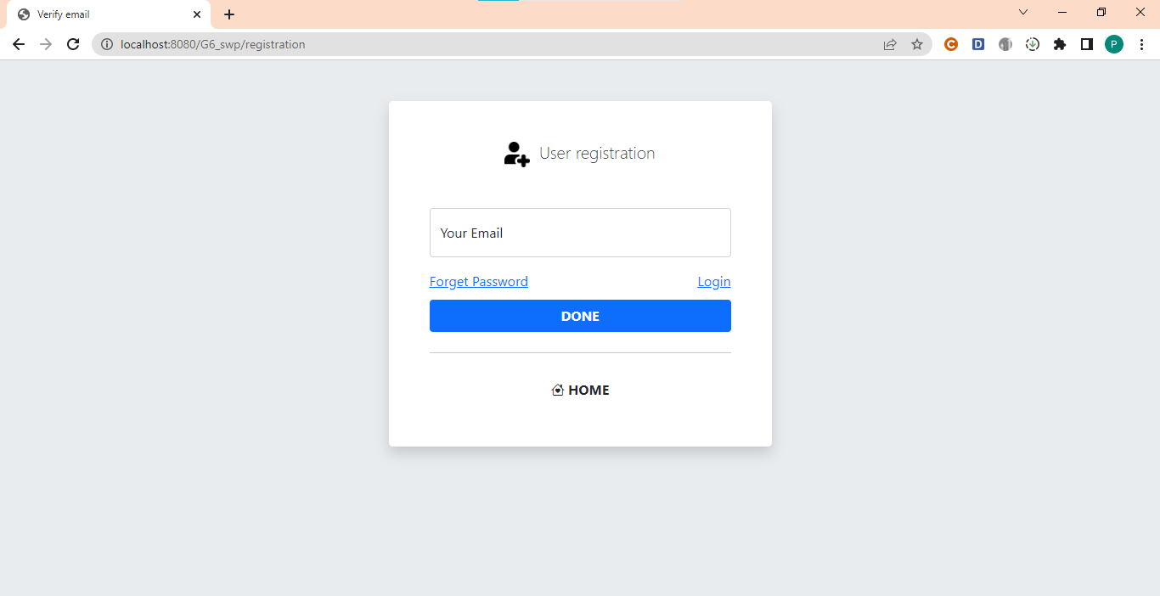

After you had a account, you need login to the system. Example form for login as below.

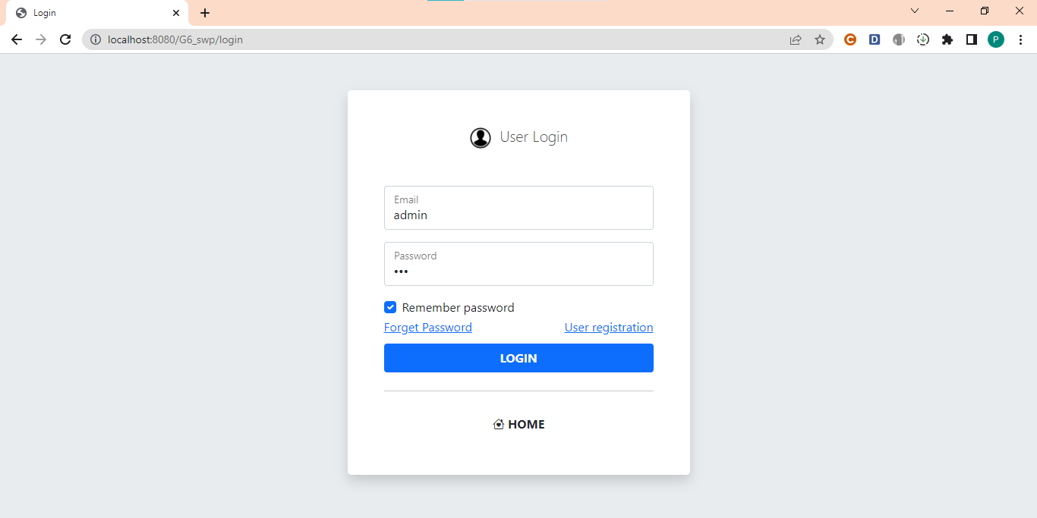

After you login successful, you can change your password to make it easy to remember.

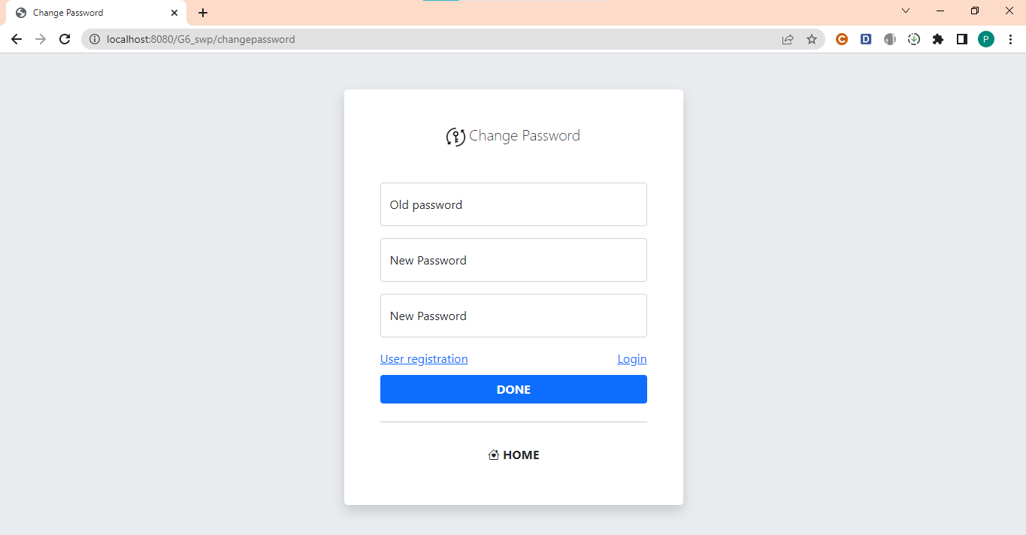

If you forgot your password, you can reset password. All you need to do is enter the correct email address that you have registered, we will send a confirmation email to your mailbox.

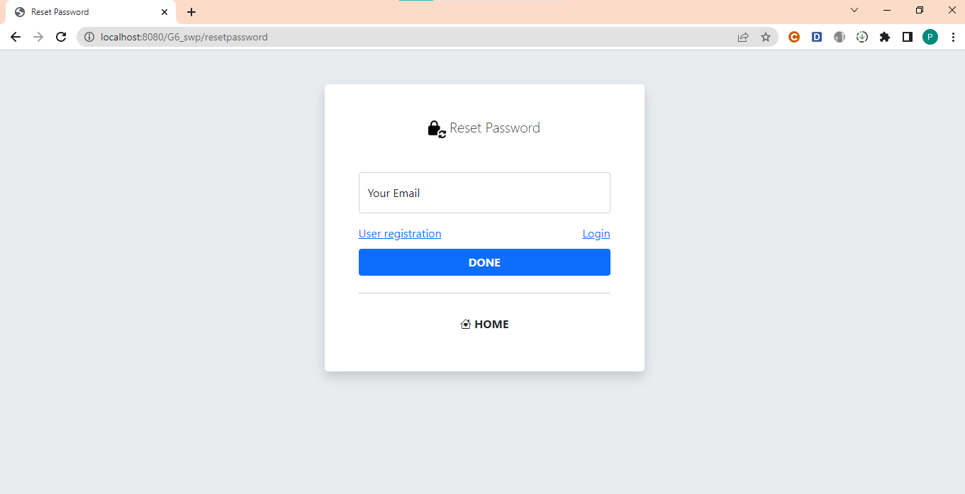

Here is the User Profile. In this screen, you can see all your information of your account: role, rollnumber, Fulll Name, Date of birth, Gender, Mobile, Email, Link Facebook, Image. You can also change your information.

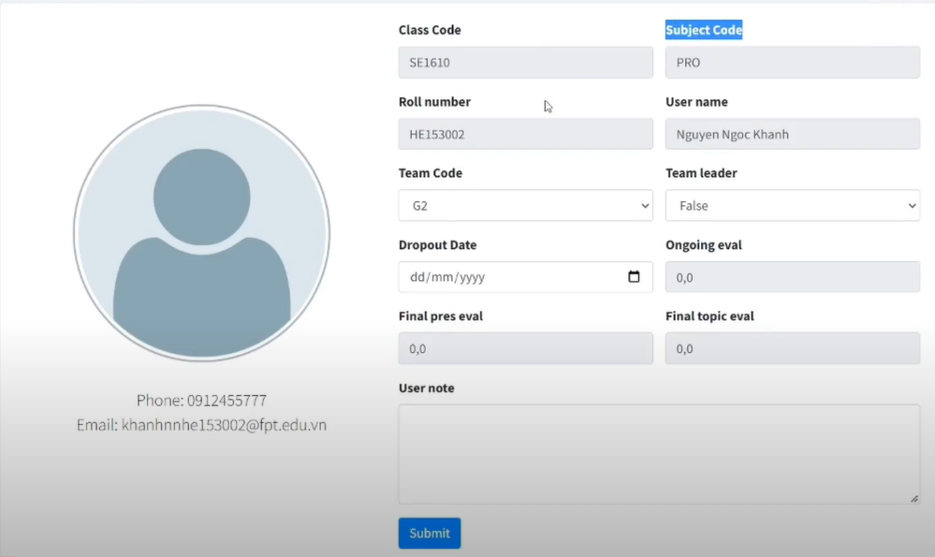

## 3. Admin

Step 1: First at the user's home page click on the login button

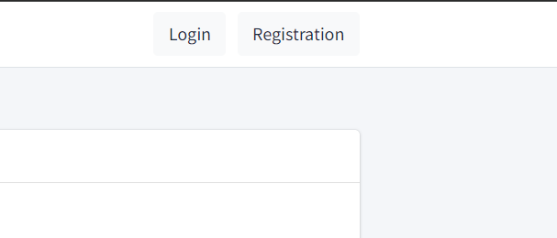

Step 2: then log in to your admin account (email: admin, password: 123)

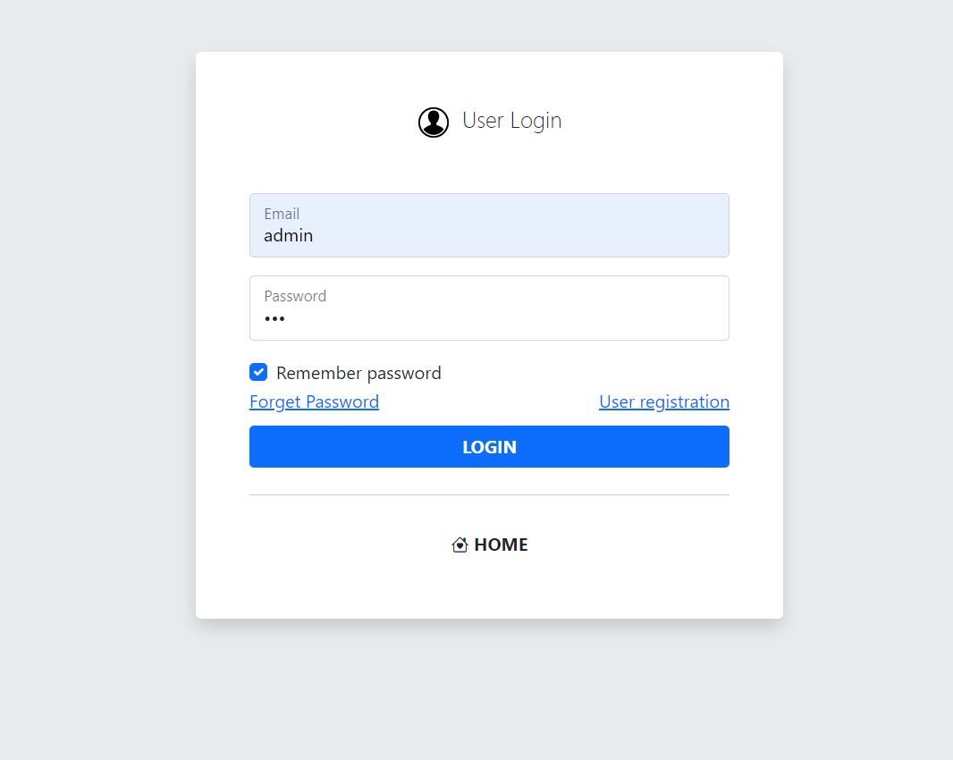

Step 3: After logging in, open the sidebar to show the admin functions

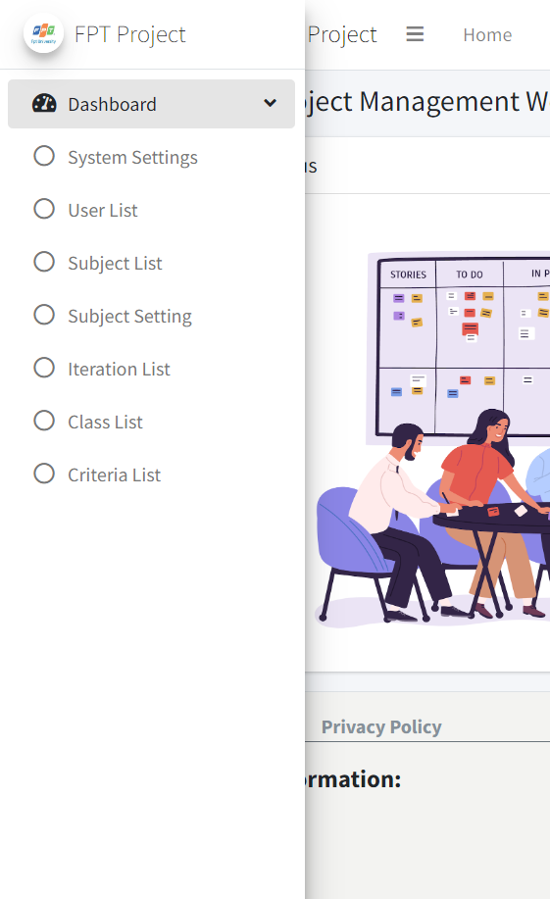

Step 4: Click on SYSTEM SETTING to display the setting list, in the list you can filter by Setting Type, Status and search by Title.

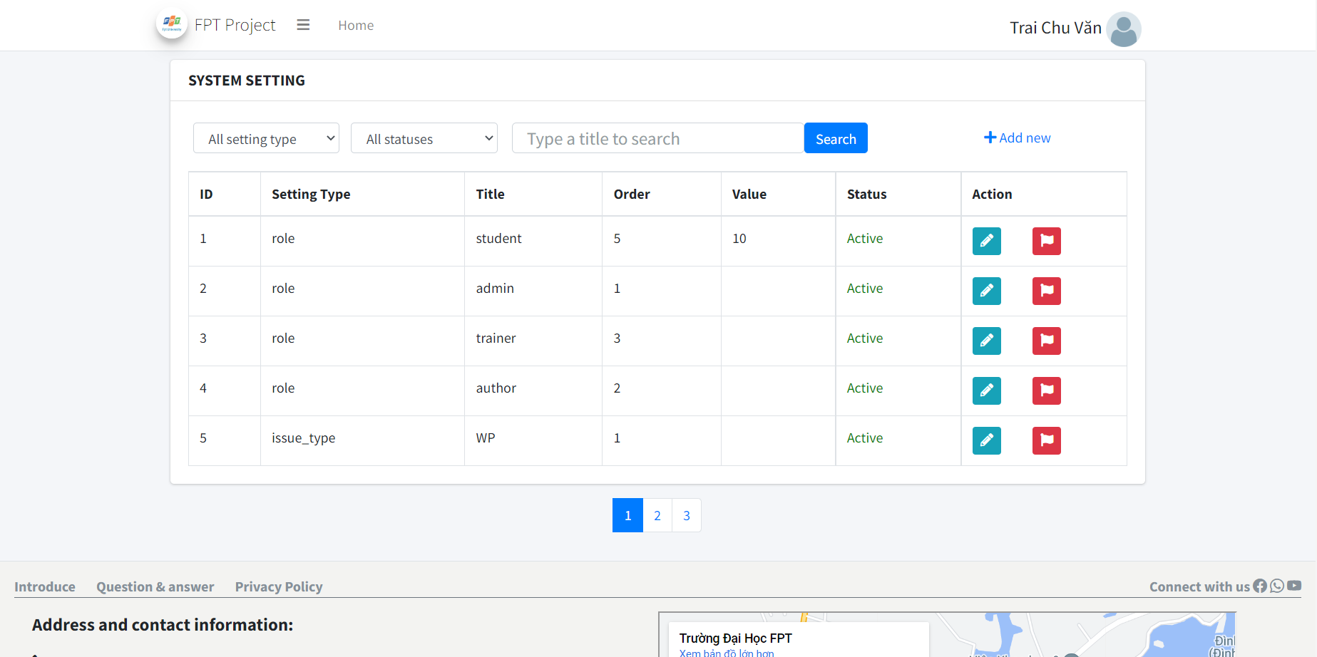

Step 5: Click the Add new button to add settings.

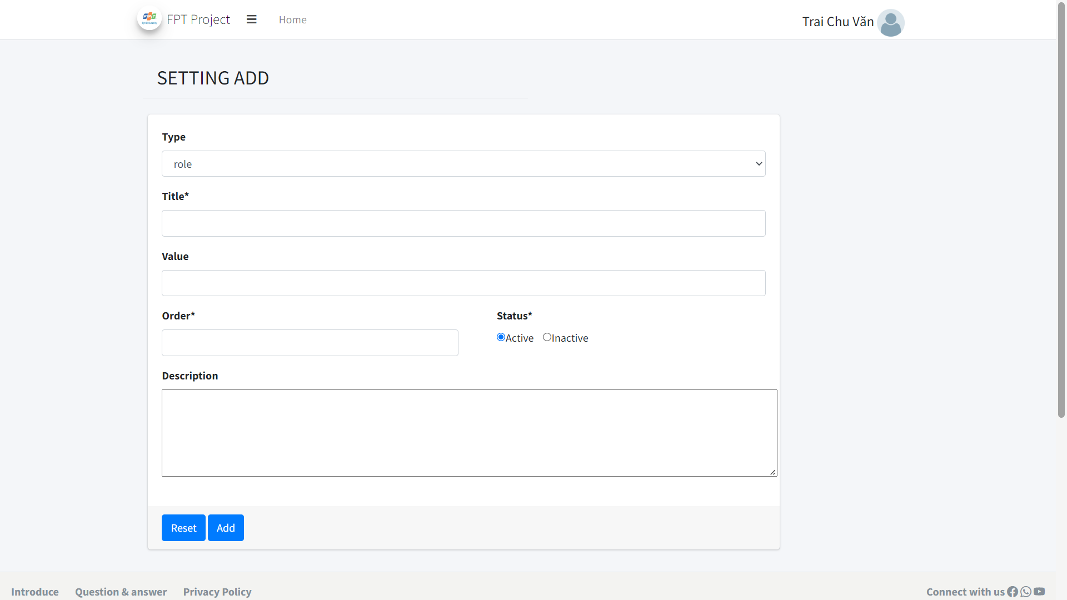

Step 6: Click the pen-shaped button in the setting list to go to the setting detail and edit the setting information

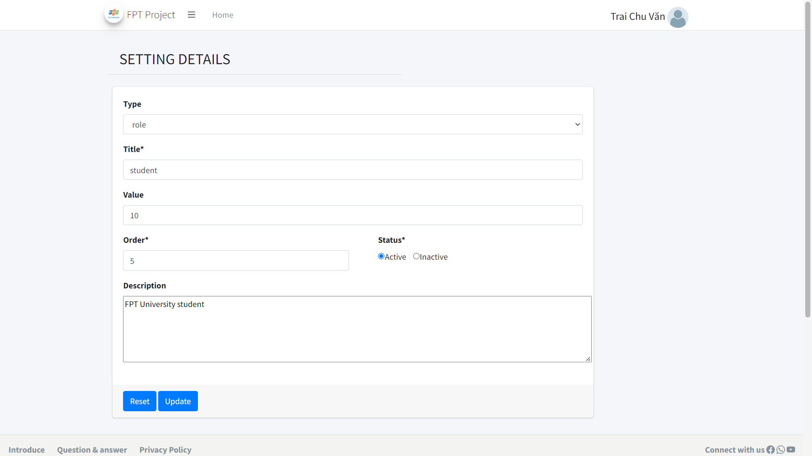

Step 6: Click the flag button to switch the status of the setting

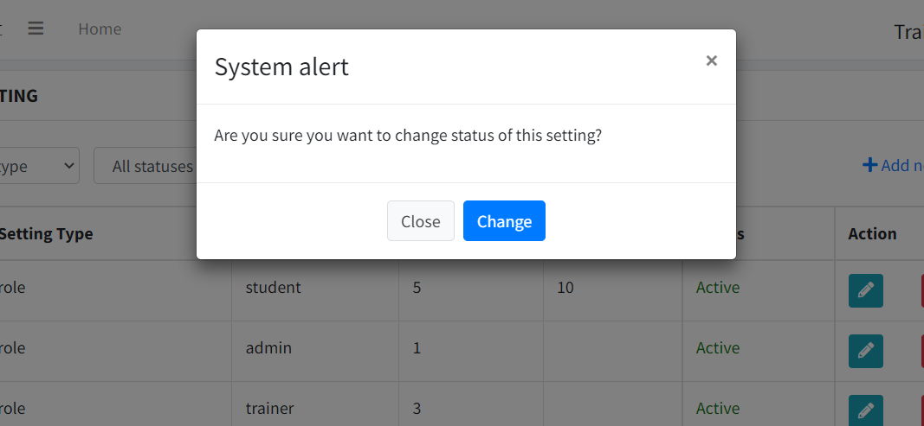

Step 7: Click USER LIST in the sidebar to display the user list (filter by Role, Status and search by user name)

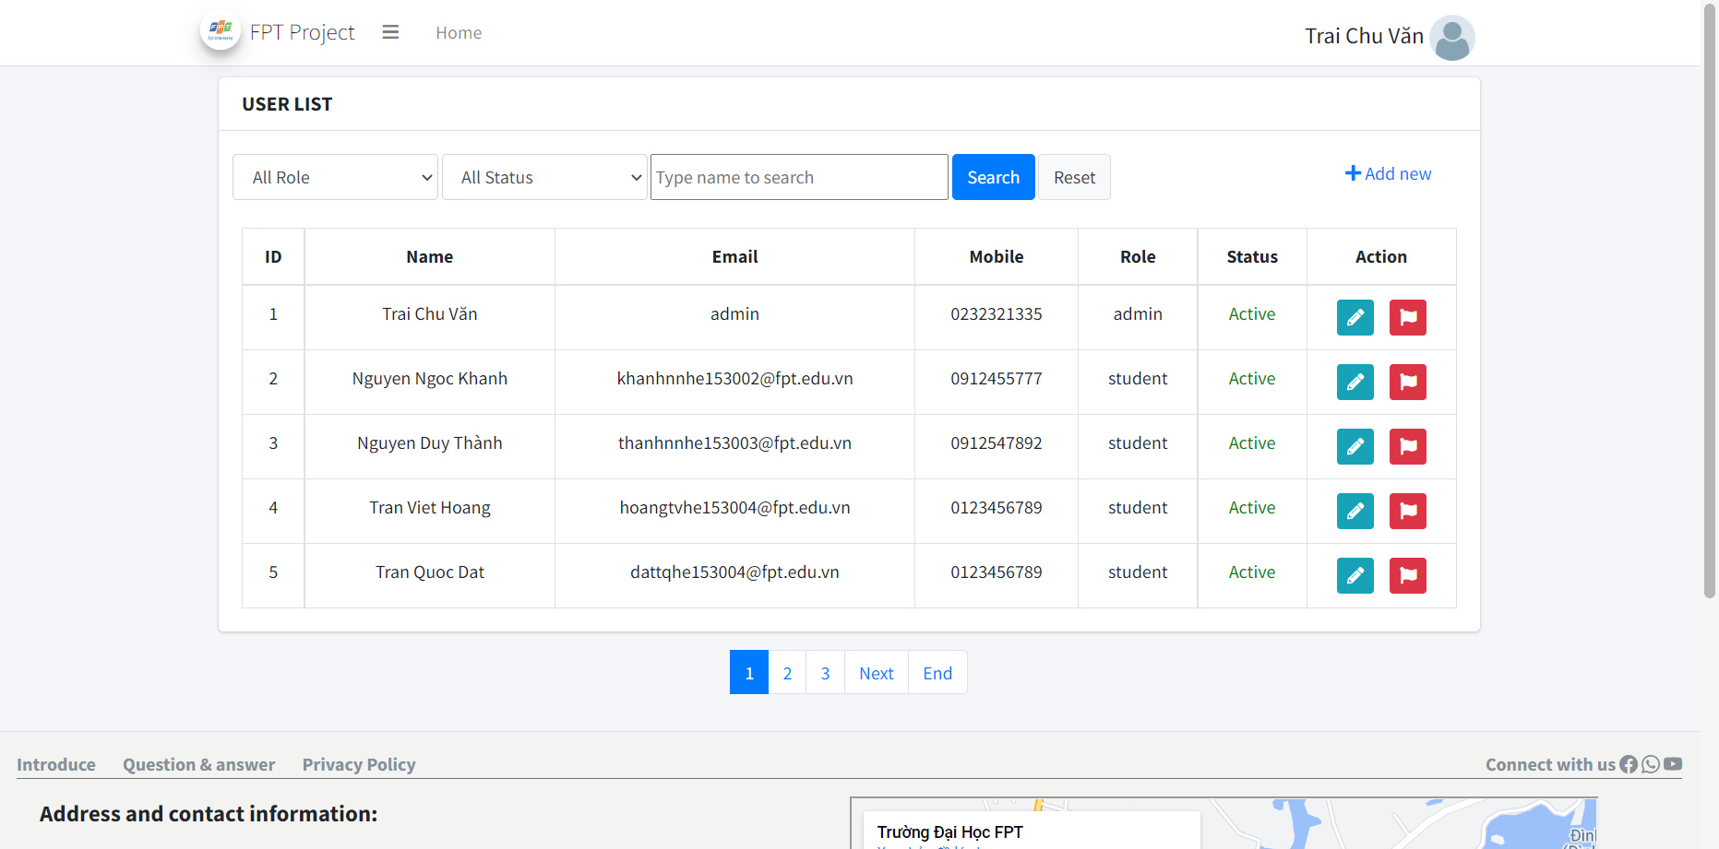

Step 8: Click on the pen-shaped button to go to user detail to edit user information

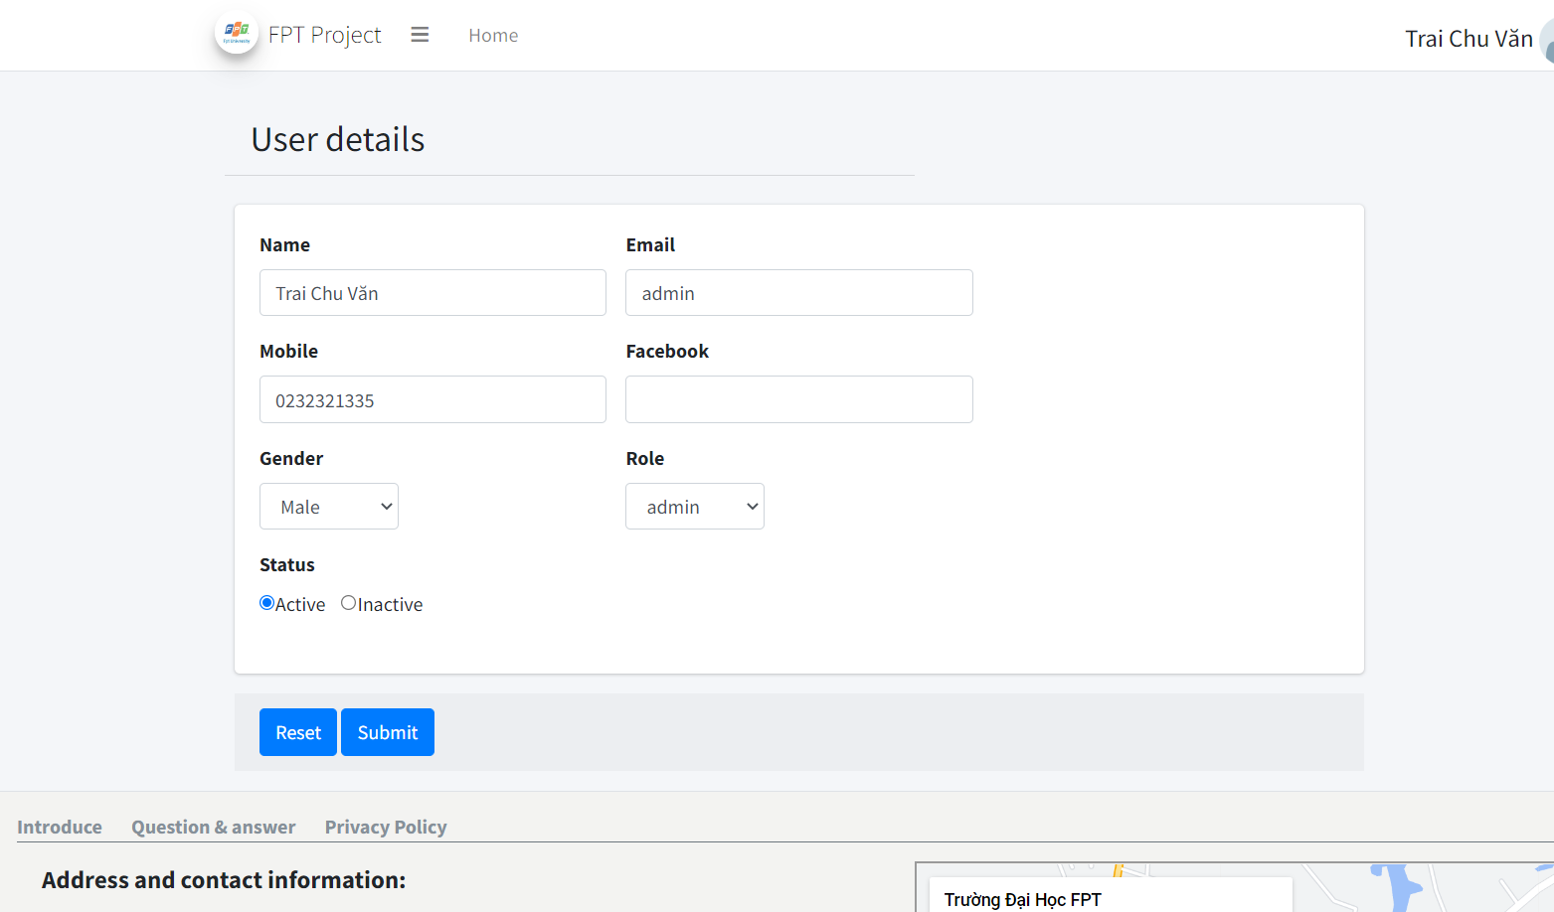

Step 9: Click on the flag button to change the user's status

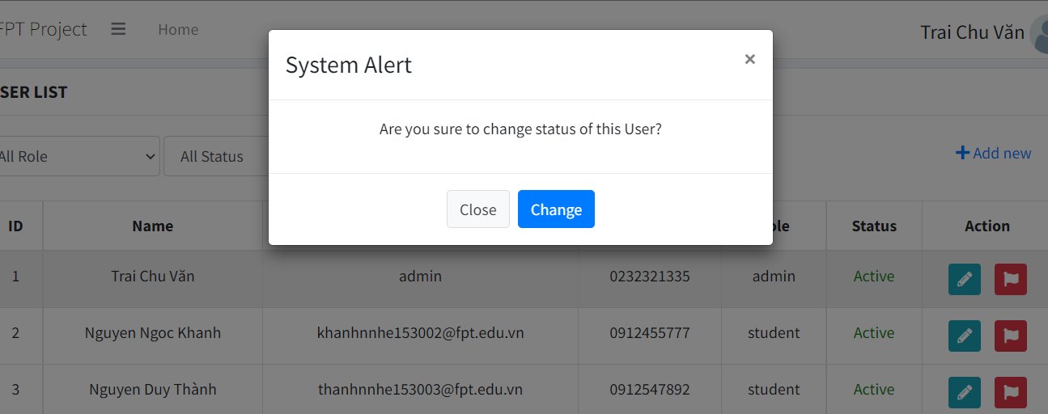

Step 10: Click on the subject list to display the subject list (filter by Status, search by Subject Code and name)

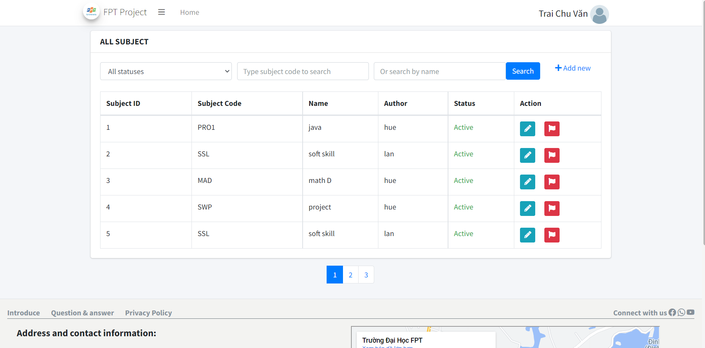

Step 11: Click on add new to add a new subject

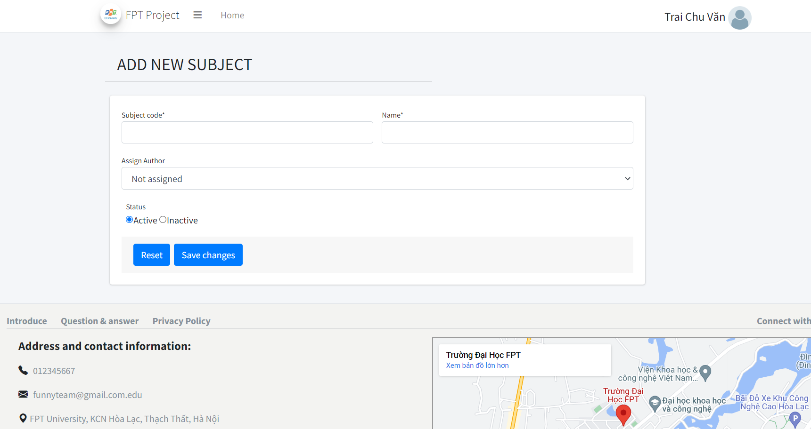

Step 12: Click the pen-shaped button to edit the subject's information.

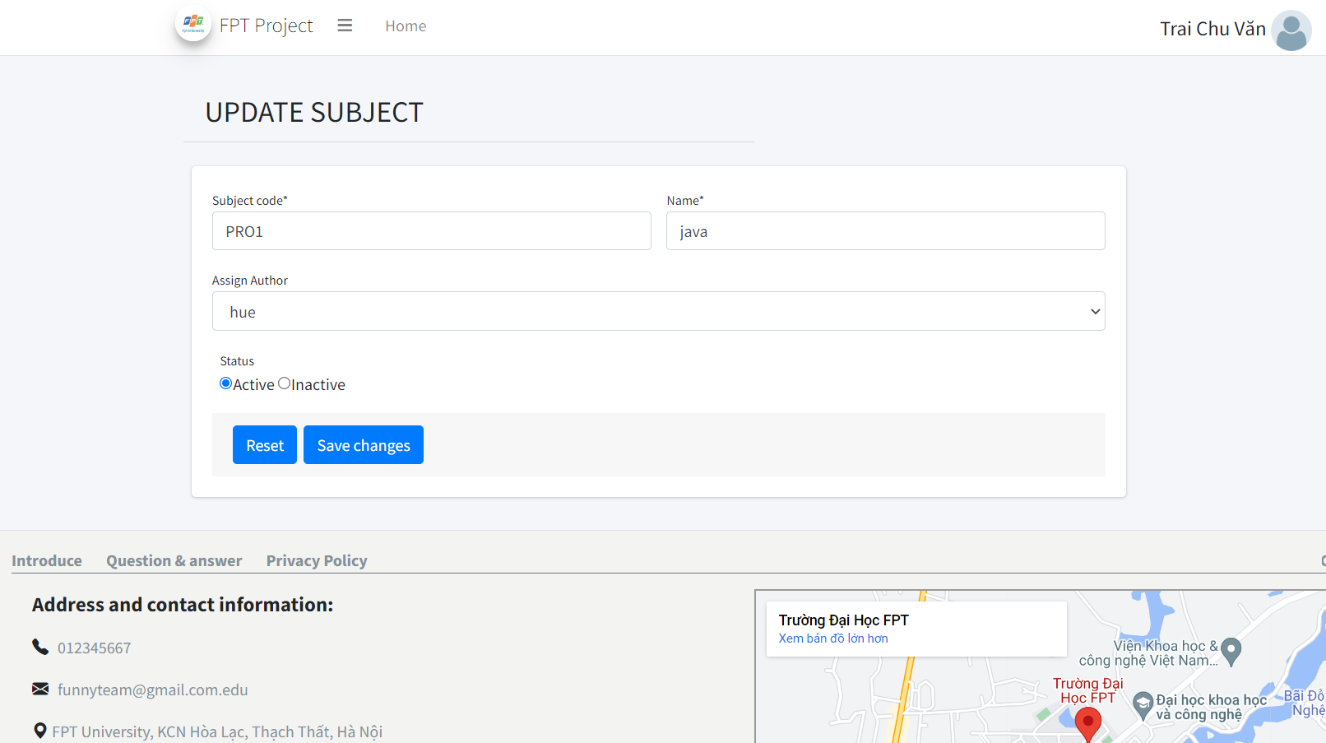

Step 13: click on the flag to change the status of subject

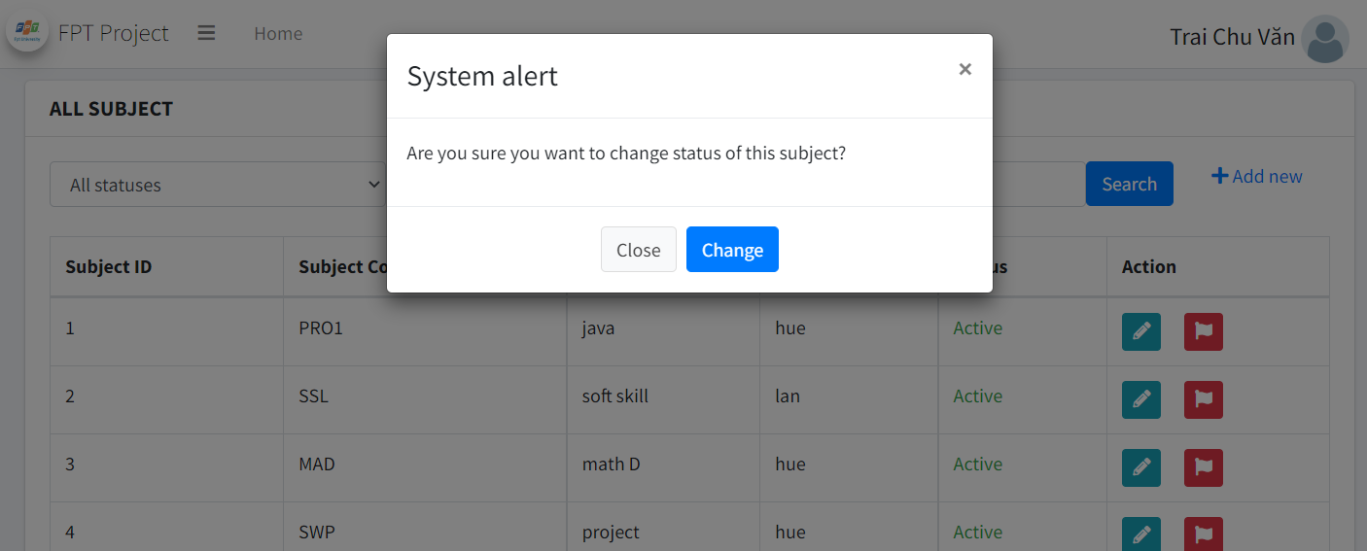

## 4. Author

This workflow is for feature Author and is accessed by 2 roles in system is Author and Admin. In this workflow, as a Author and Admin, you can access all data of assigned’s class while Student just can view only.

To begin, you need to login with an account has role is **Author**. Example:

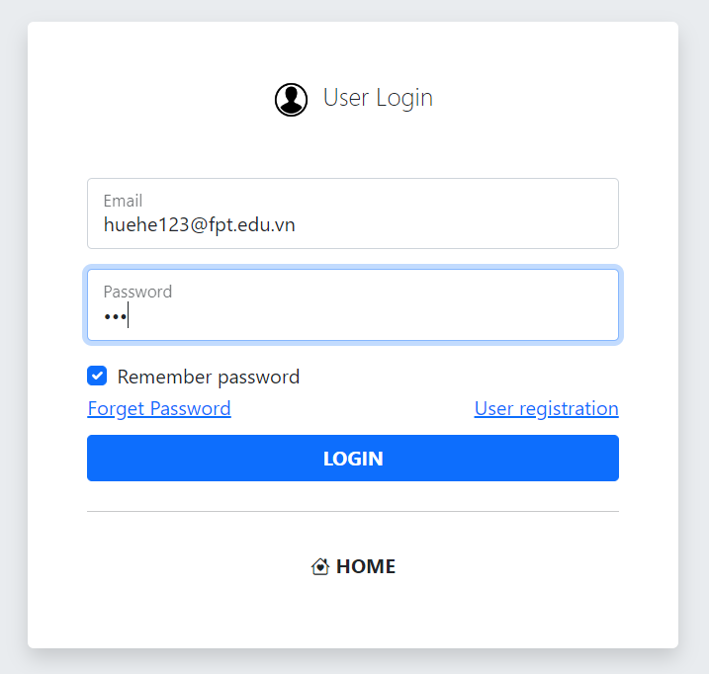

And then you get the dashboard:

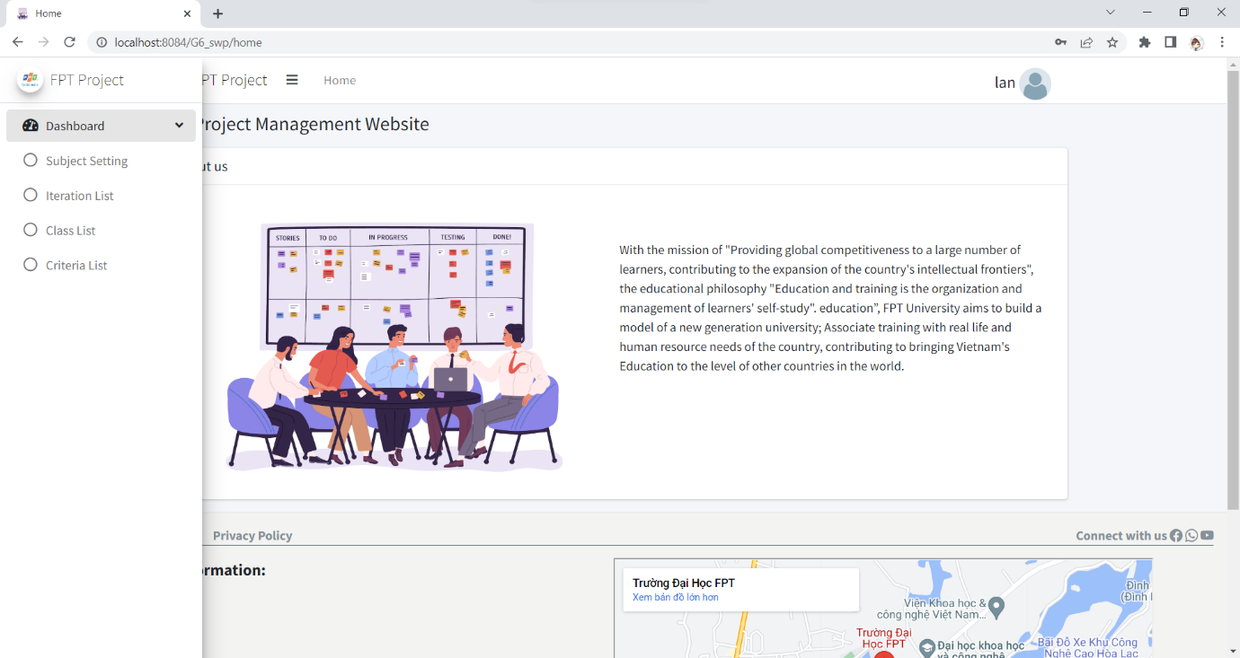

In this flow, it includes: Subject Setting List, Iteration List, Criteria List,

Class List.

With **Subject Setting List**, you click on this in Dashboard and you are redirect to this milestone screen.

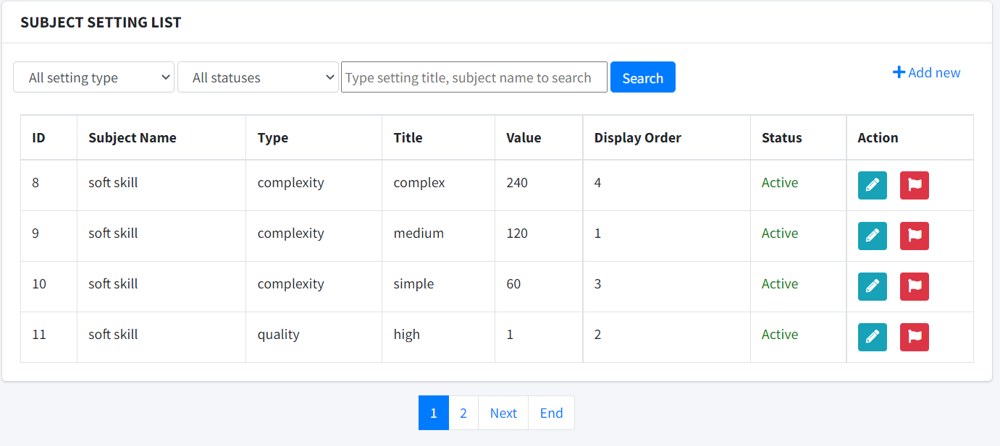

You can use filter to filter out what information you need:



You click this button  to view details and update information if needed.

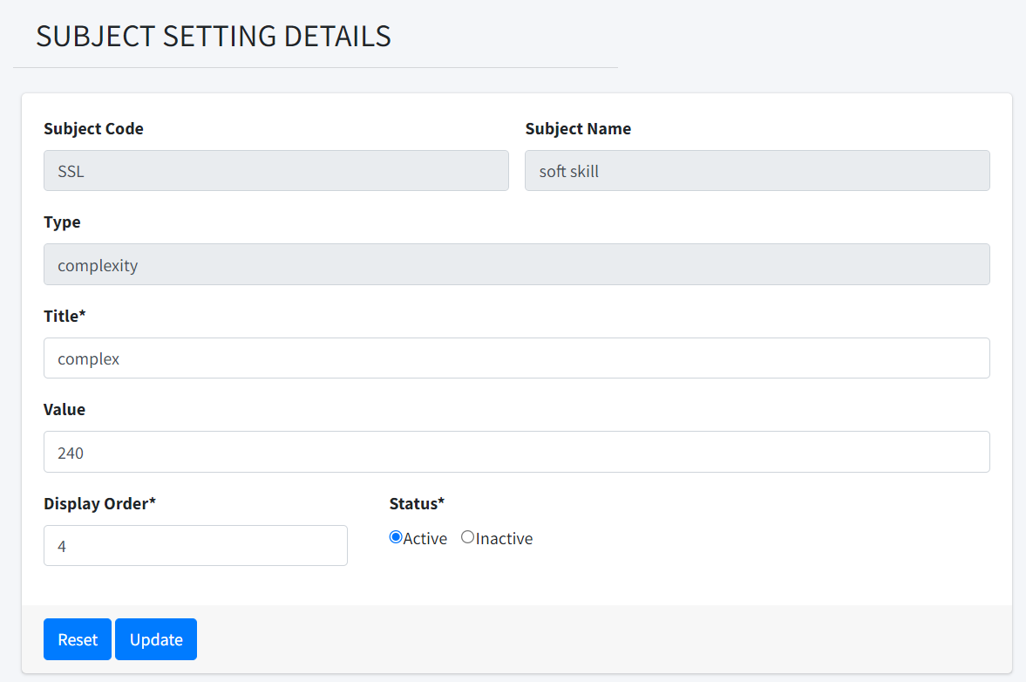

You edit and click Update to update information or click Reset to clear all the changes.

Update success and system return the notification.

You click this buttonto change status of a milestone to Open, Close or Cancel. You will be ask to confirm you decision before it change status.

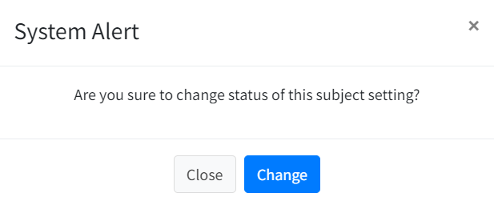

You click this button  to add a new milestone. First, you need to choose a class for this new **Subject Setting List**

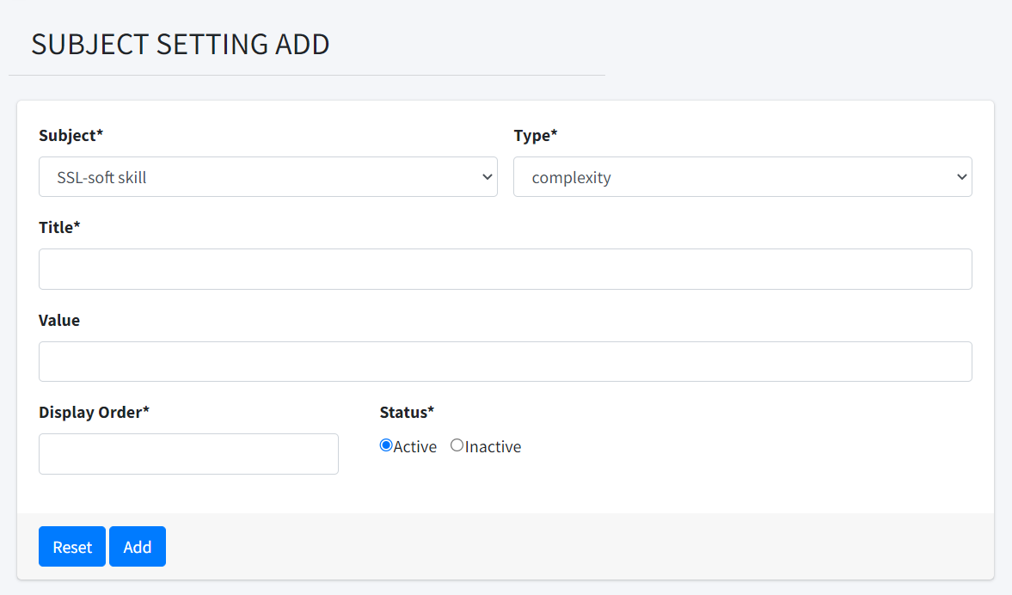

And then click Create to add new Team or click Reset to get original form.

## Next one is ****ITERATION LIST****. You click on ****ITERATION LIST**** on Dashboard to get to this screen.

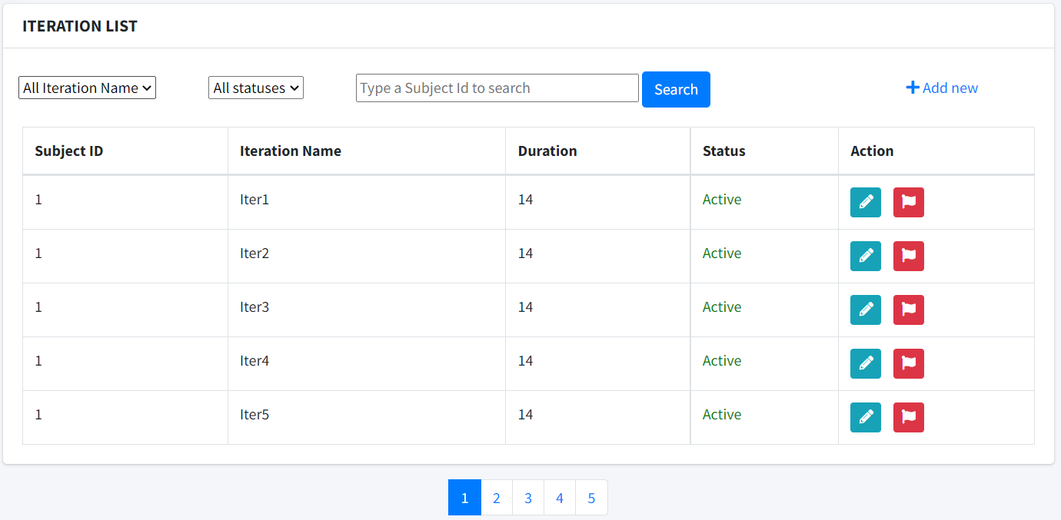

You can use filter to filter out what information you need:

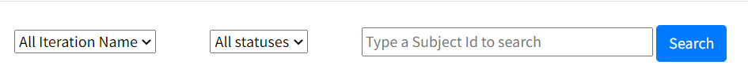

You click this button  to view details and update information if needed.

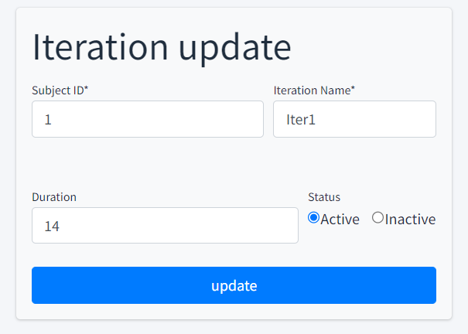

You edit and click Update to update information or click Reset to clear all the changes.

Update success and system return the notification.

You click this buttonto change status of a milestone to Open, Close or Cancel. You will be ask to confirm you decision before it change status.



You click this button  to add a new milestone. First, you need to choose a class for this new **Subject Setting List**

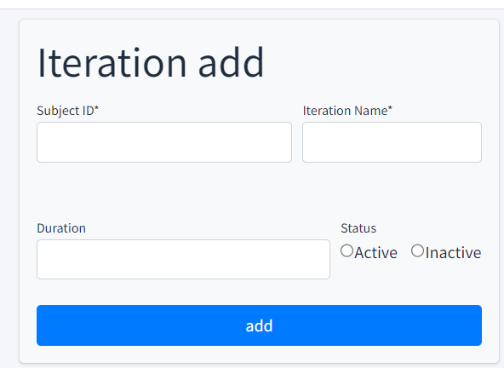

And then click Create to add new Team or click Reset to get original form.

## Next one is ****CLASS LIST****. You click on ****CLASS LIST**** on Dashboard to get to this screen.

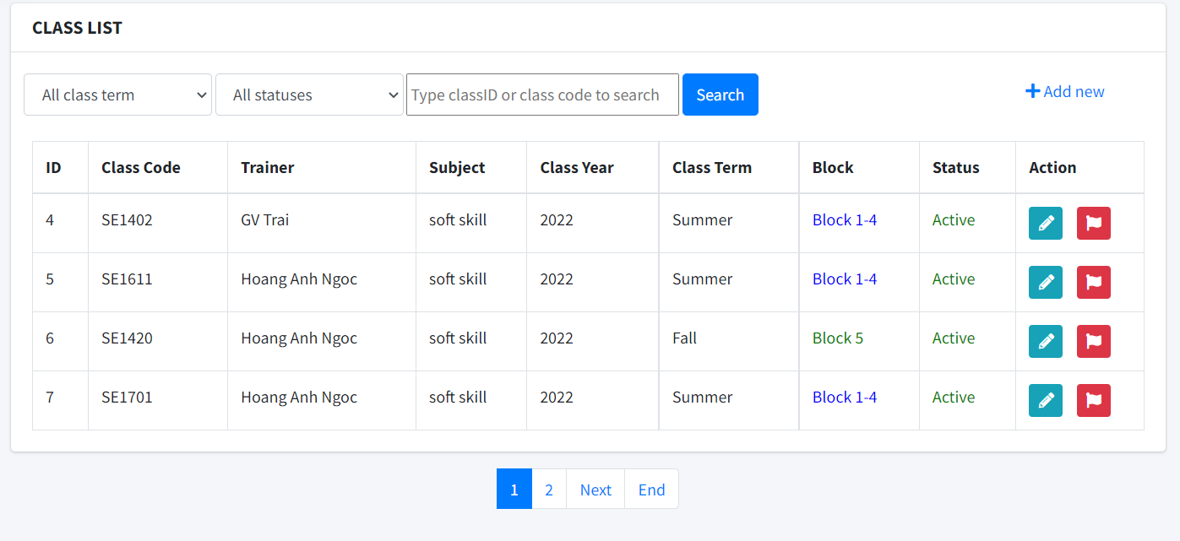

You can use filter to filter out what information you need:

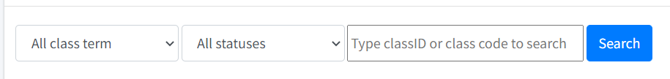

You click this button  to view details and update information if needed.

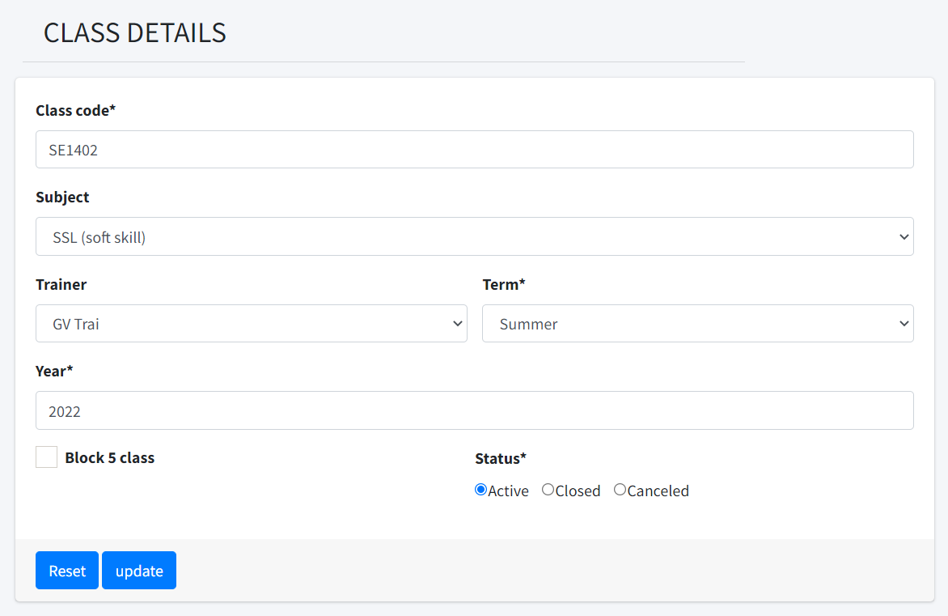

You edit and click Update to update information or click Reset to clear all the changes.

Update success and system return the notification.

You click this buttonto change status of a milestone to Open, Close or Cancel. You will be ask to confirm you decision before it change status.



You click this button  to add a new milestone. First, you need to choose a class for this new **CLASS LIST**

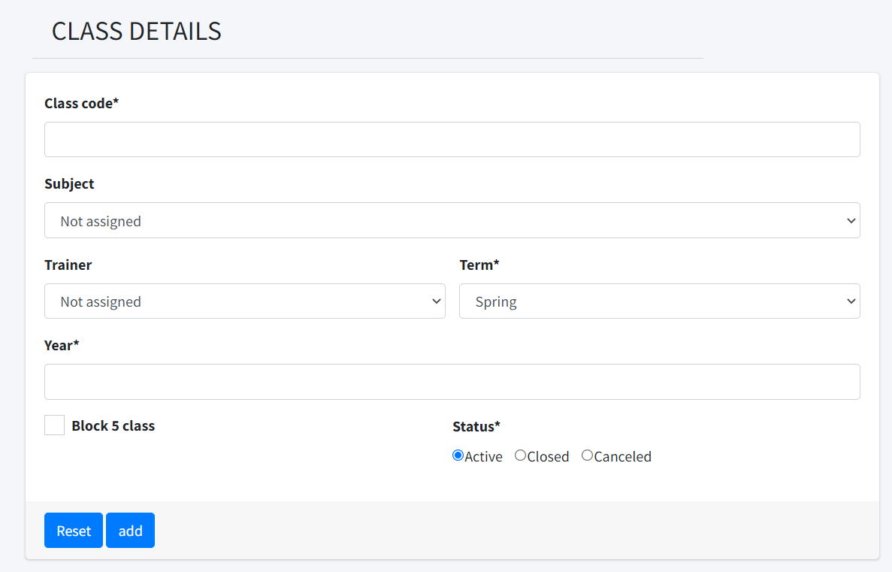

And then click Create to add new Team or click Reset to get original form.

## Next one is ****CRITERIA LIST****. You click on ****CRITERIA LIST**** on Dashboard to get to this screen.

This workflow is for feature Author and is accessed by 3 roles in system is Author, Admin, Trainer. In this workflow, as a Author, Admin, Trainer, you can access all data of assigned’s class while Student just can view only.

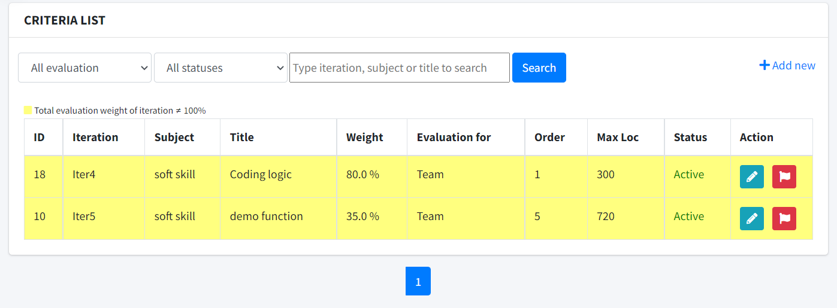

You can use filter to filter out what information you need:



You click this button  to view details and update information if needed.

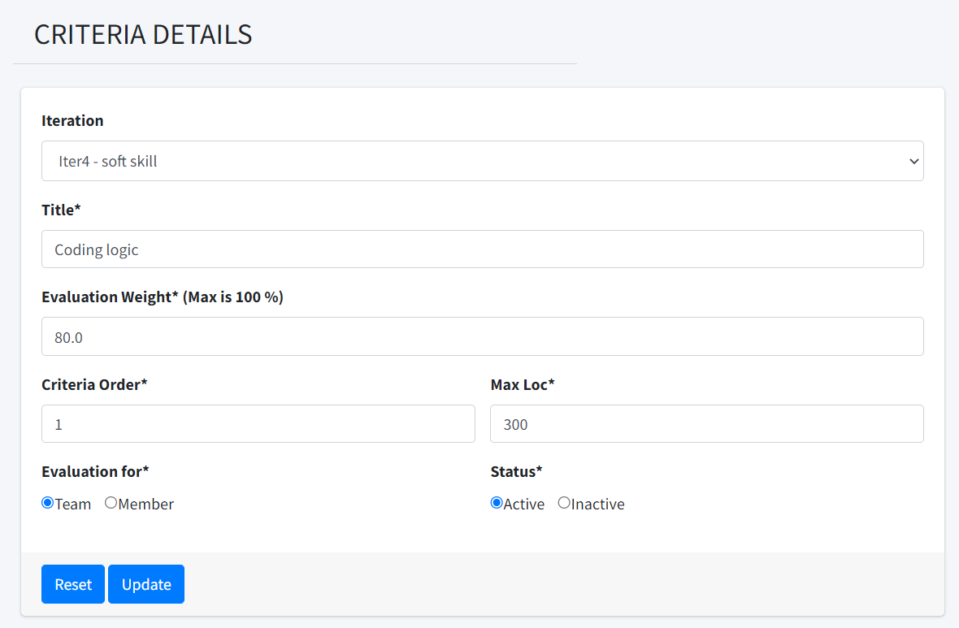

You edit and click Update to update information or click Reset to clear all the changes.

Update success and system return the notification.

You click this buttonto change status of a milestone to Open, Close or Cancel. You will be ask to confirm you decision before it change status.



You click this button  to add a new milestone. First, you need to choose a class for this new **CRITERIA LIST**

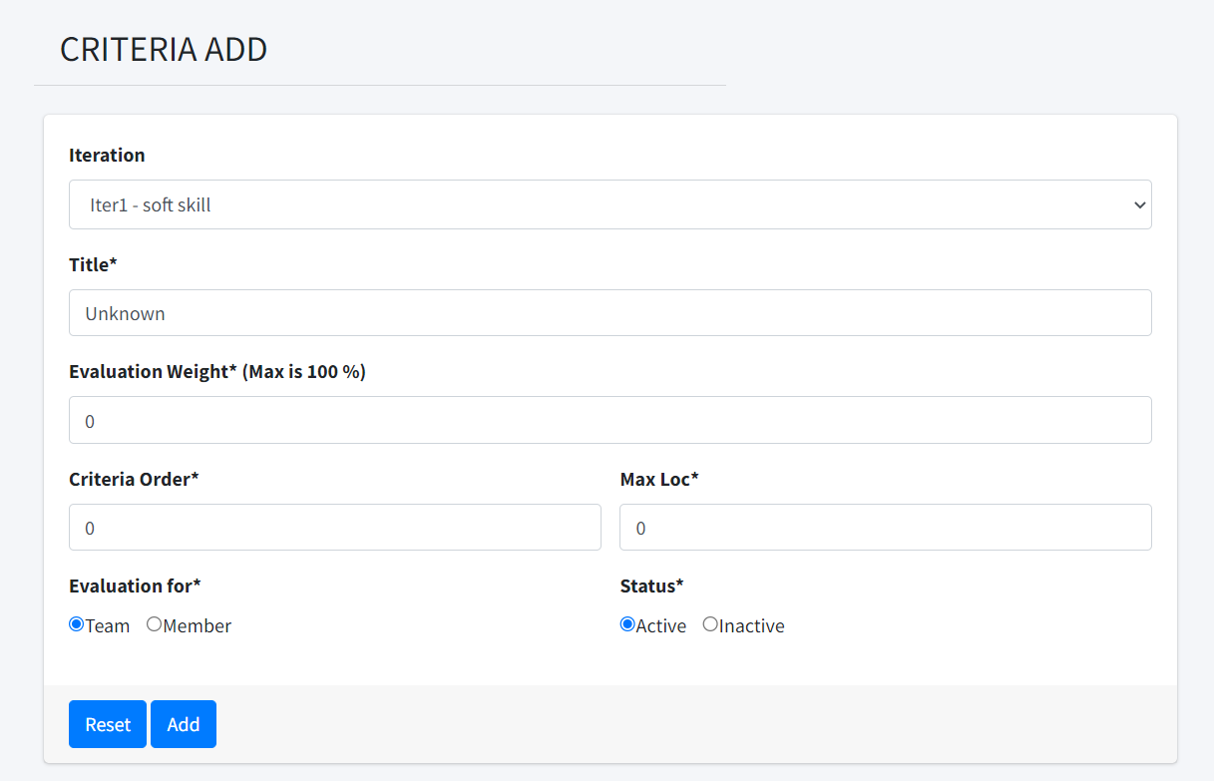

And then click Create to add new Team or click Reset to get original form.

## 6. Trainer

This workflow is for feature Trainer and is accessed by 2 roles in system is Trainer and Student. In this workflow, as a Trainer, you can access all data of assigned’s class while Student just can view only.

To begin, you need to login with an account has role is **Trainer.** Example: 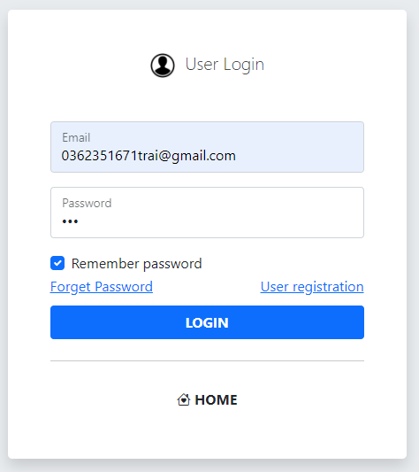

And then you get the dashboard: 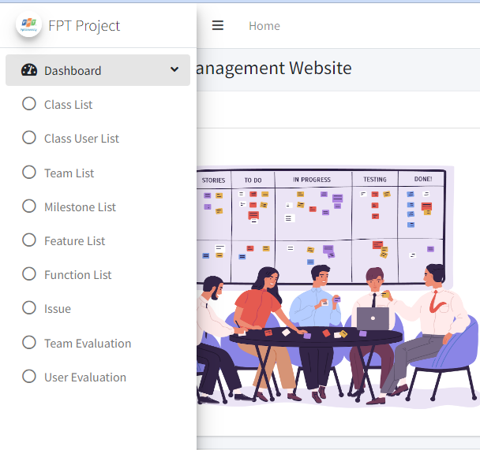

In this flow, it includes: Milestone List, Team List, Class User List, Loc Evaluation, Team Evaluation and User Evaluation.

**With Milestone List**, you click on this in Dashboard and you are redirect to this milestone screen. 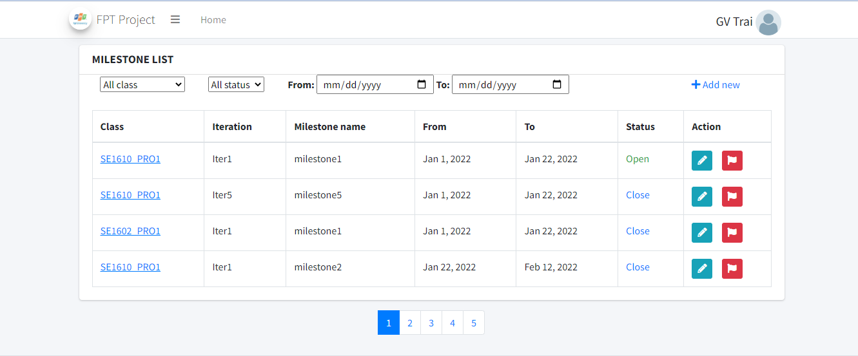

You can use filter to filter out what information you need:



You click this button  to view details and update information if needed.

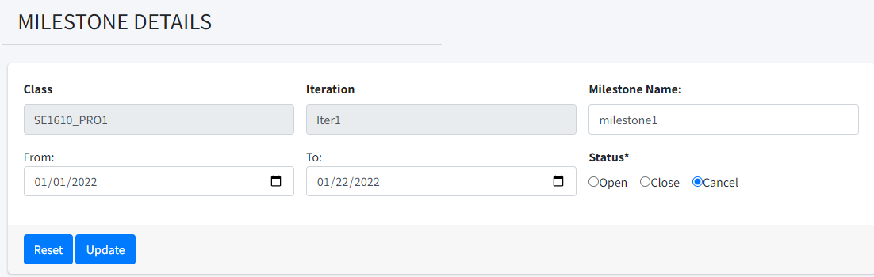

You edit and click Update to update information or click Reset to clear all the changes.

Update success and system return the notification.

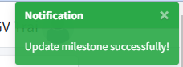

You click this buttonto change status of a milestone to Open, Close or Cancel. You will be ask to confirm you decision before it change status.

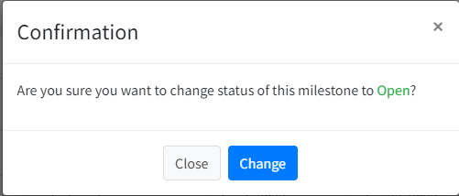

You click this button  to add a new milestone. First, you need to choose a class for this new milestone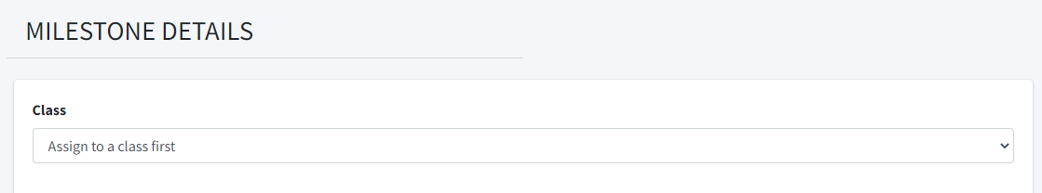

After choose, you have this form to add information for new milestone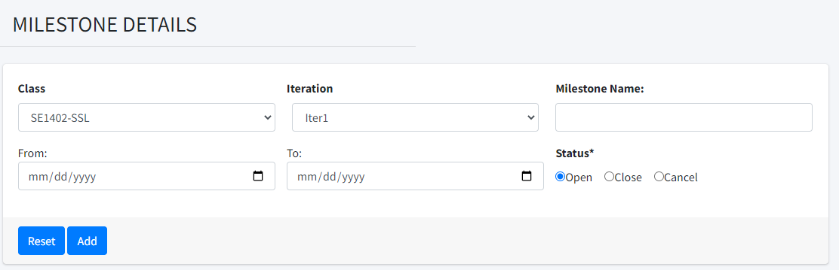

You fill and click Add button to add or Reset button to reset to beginned form. Add success and you get this notification.

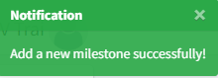

The next one is **Team List**, you click on Team List on Dashboard and it redirect you to this screen.

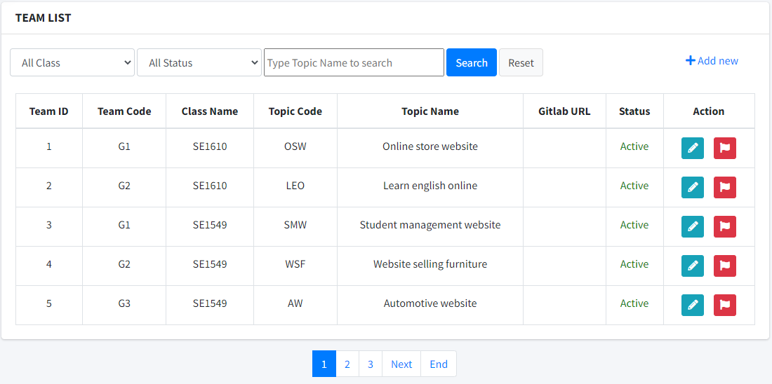

You can use filter: 

to get what information you need.

You can click button  to view details and update.

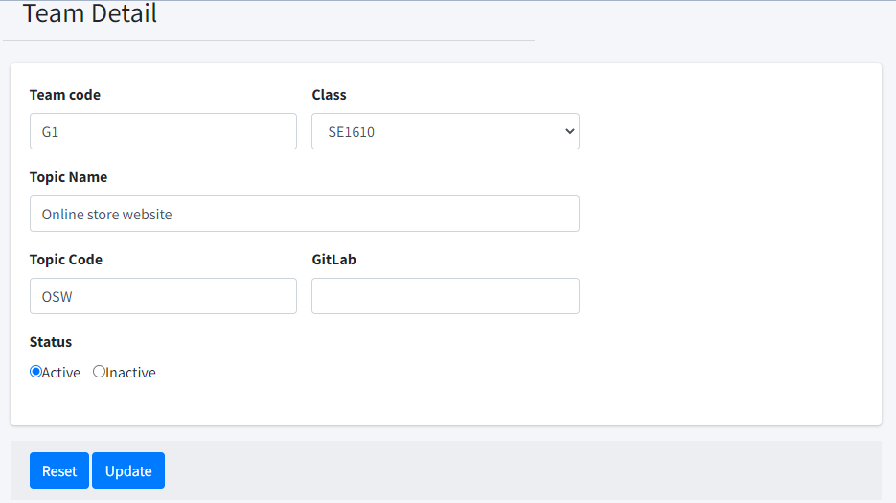

You fill the form with your updated informations and click Update to update. You can click Reset to clear all the changes and it come back to origin information.

You click button  to change status of Team. You will get need to confirm to make sure that you want to change it status:

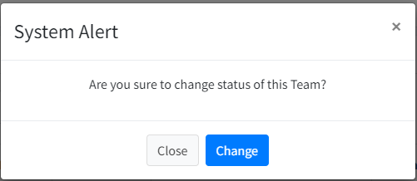

You can click  to add new Team.

Filled all information in this form: 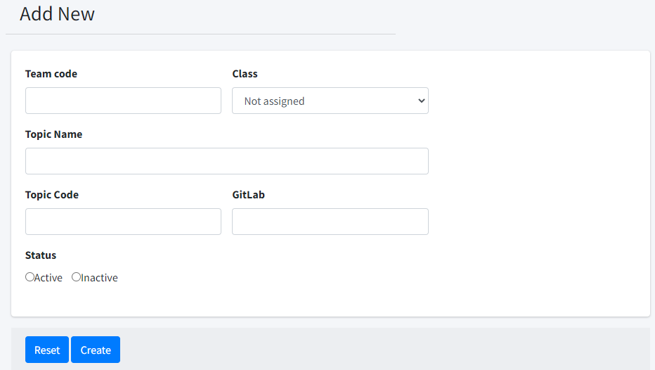

And then click Create to add new Team or click Reset to get original form.

Next one is **Class User List**. You click on Class User List on Dashboard to get to this screen.

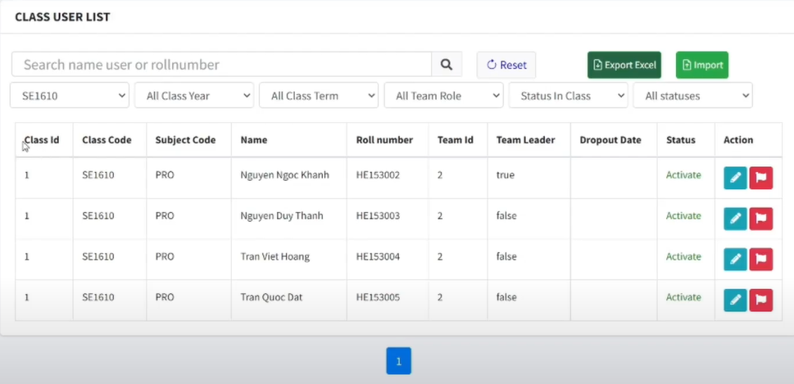

You can use filter 

You can Export data to Excel file by click on button 

You can Import data by click on button 

You click this button  to change status of Class User. You will get confirmation message:

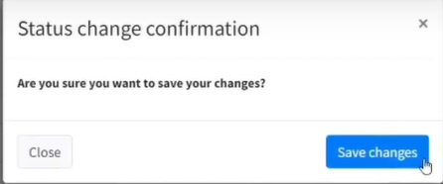

You can see details and update by click on 



Click submit to update information.

Submit success notification: 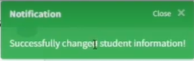

With Loc Evaluation, you can access it directly from Tracking screen.

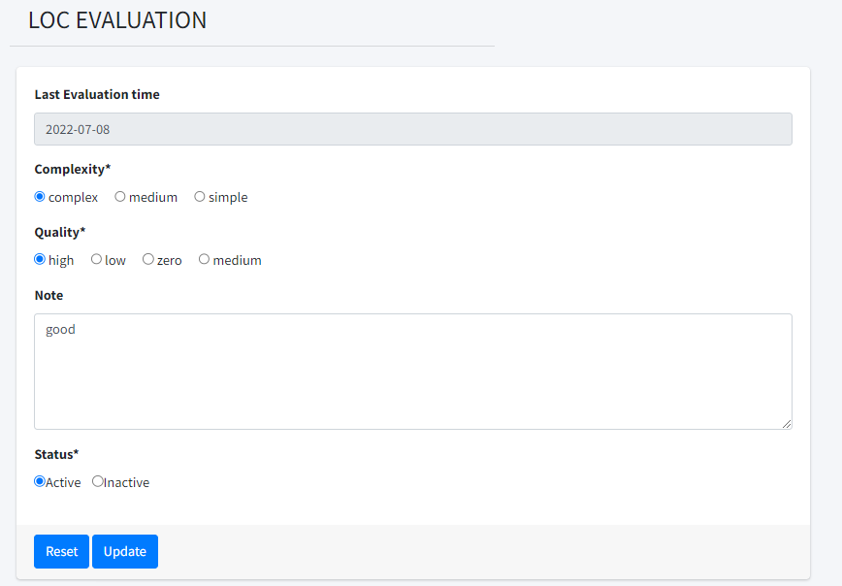

If already have Loc Evauation for this Tracking, you can update this evaluation and click Update to submit. It also show the Last Evaluation Time for you to know what is the last time you evaluate it.

If it not exist, you will add new evaluation:

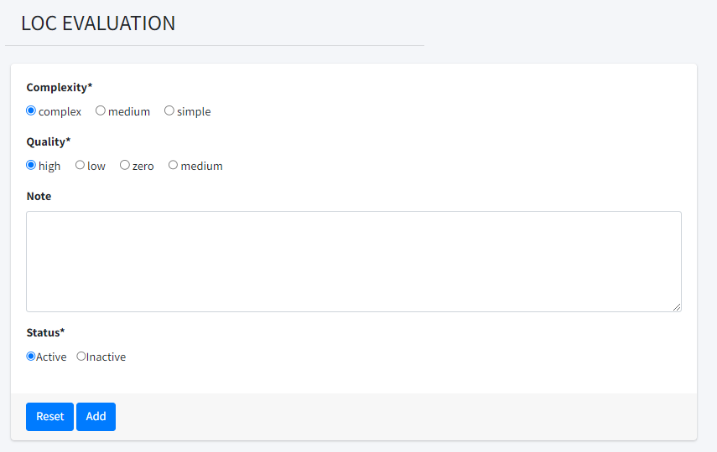

Click Add button to add new.

For Team Evaluation, you go to this screen by click Team Evaluation on Dashboard.

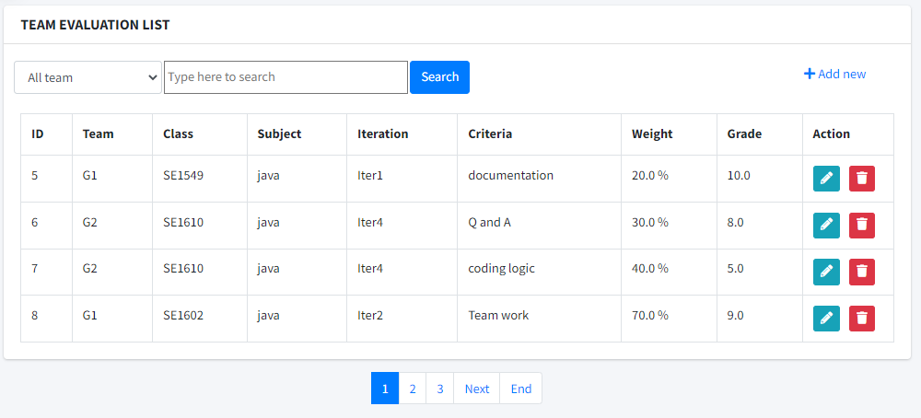

You can use filter: 

You can view details and update by click on 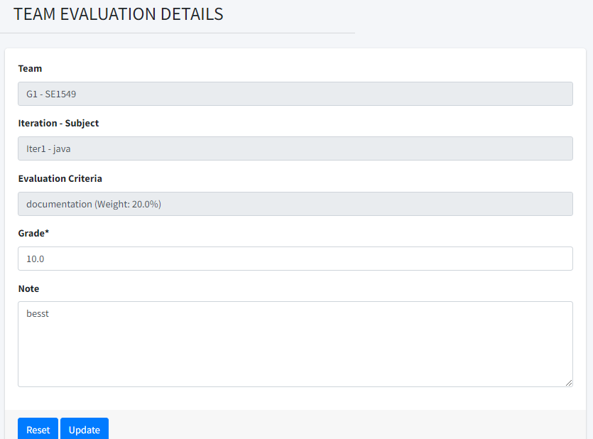

Input what you want and click Update to update. Or you can click Reset to back to original form.

Update success notification : 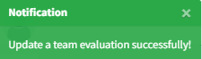

You can click this button  to delete a team evaluation. You need to confirm to make sure you want ot delete it:

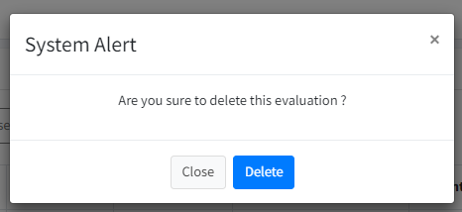

You can click this to add a new team evaluation.

First you need choose a team

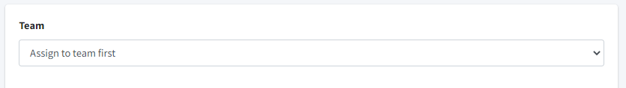

And then fill the information for team evaluation:

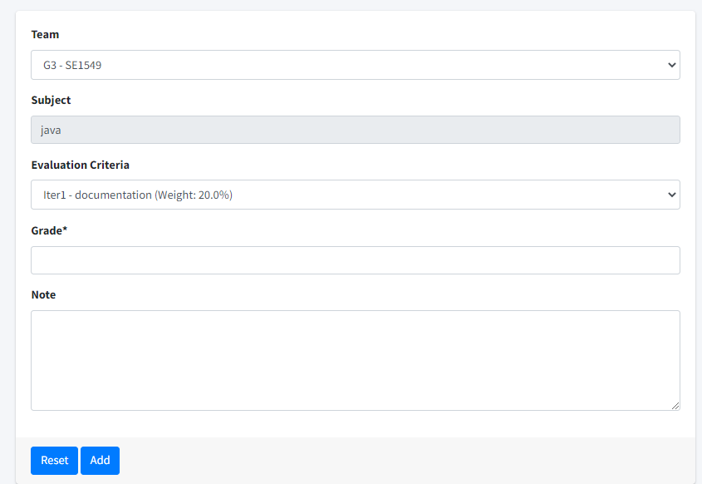

Click Add to add new or click Reset to go back to blank form.

Add success notification:

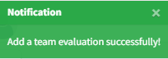

The last one is **User Evaluation.** Click on User Evaluation on Dashboard:

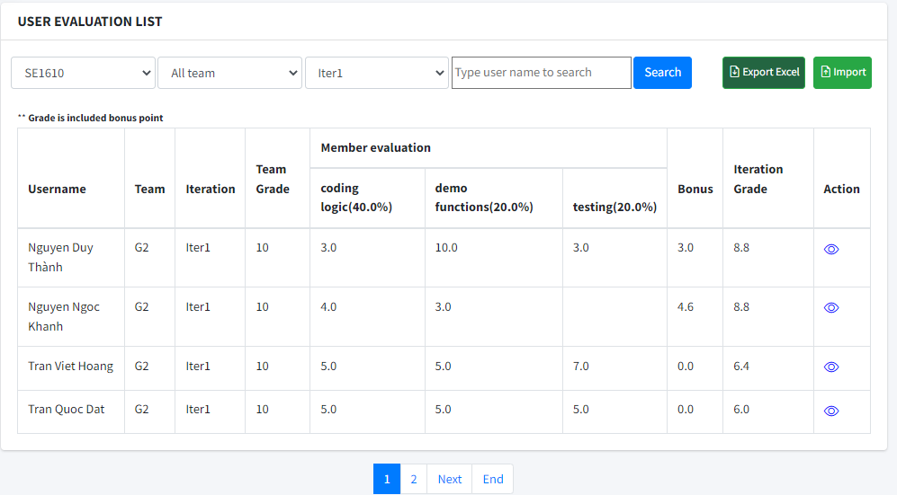

You can use filter:



You can click  to view details and update information:

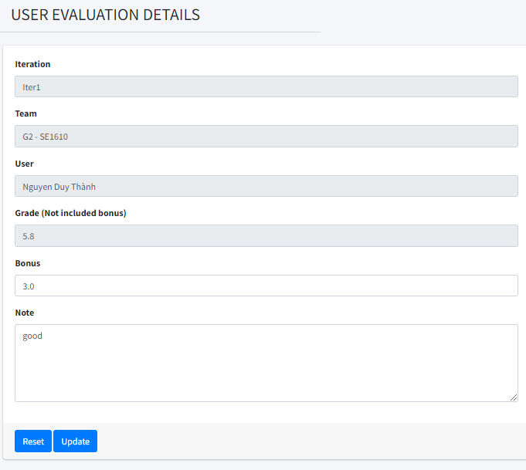

Click Update to update.

Click Reset to back to original form.

Update success notification

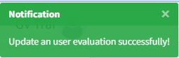

You can click on this  to export data to excel file.

And then you can click on this  to import data by excel file too.

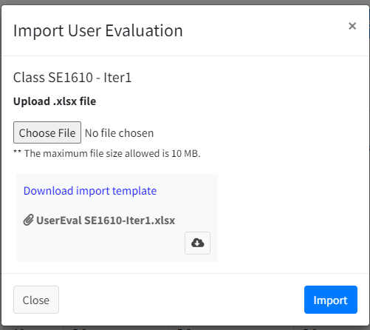

You need to Choose file with max size is 10MB following the template.

Click on Download to get template to import information.

After choose file, click  to import data.

Import success notification:

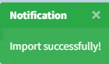

By another way, if you login as role **Student**, you can only access 3 screen Loc Evaluation, Team Evaluation and User Evaluation but with view only action.

For **Loc Evaluation**, you still see this from Tracking list:

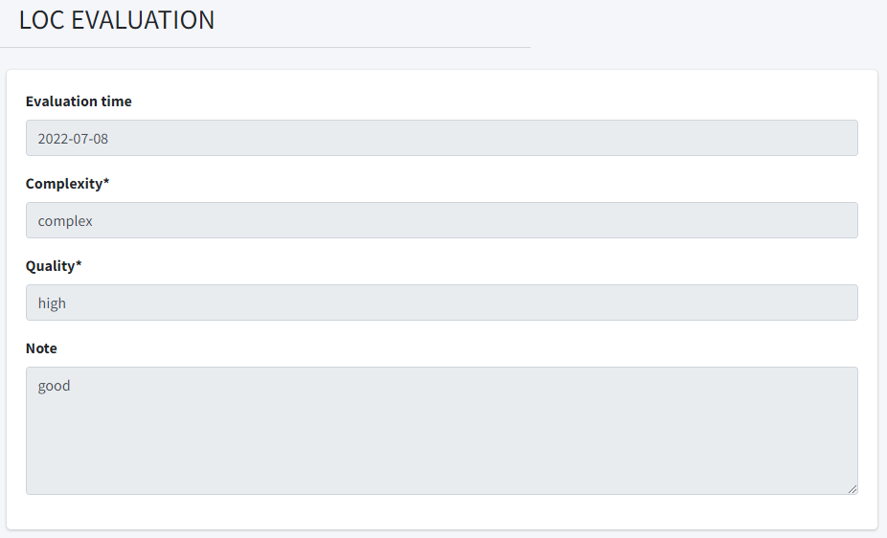

You can not add or update here.

For **Team Evaluation**, you still click on Dashboard:

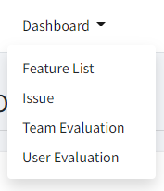

And you go to this:

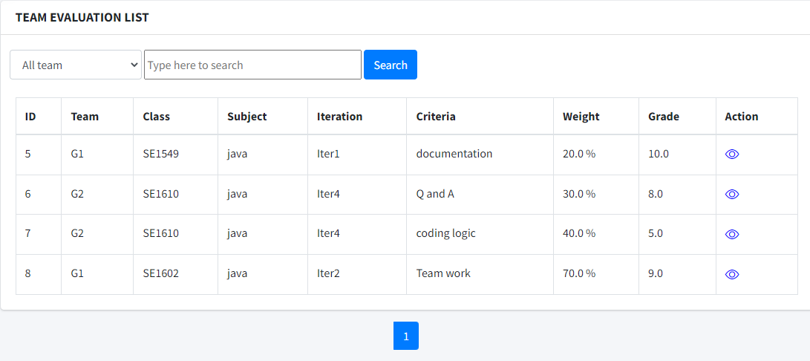

You only see data of you allocated’s team only.

You still can use filter.

You can click on  to view details.

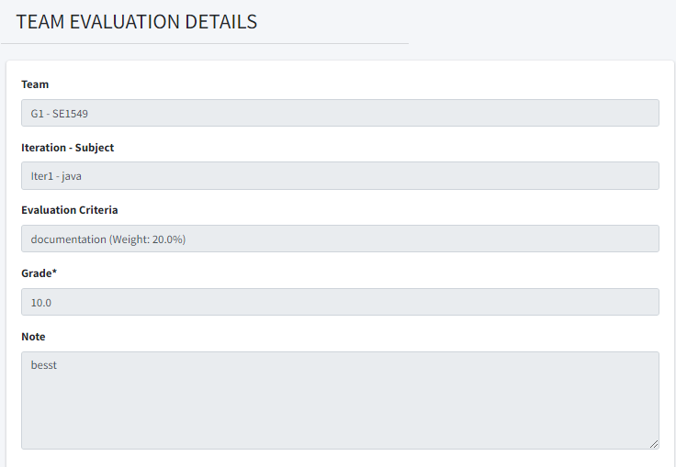

You are not allowed update here.

For User Evaluation, you click on Dashboard again and go to this screen:

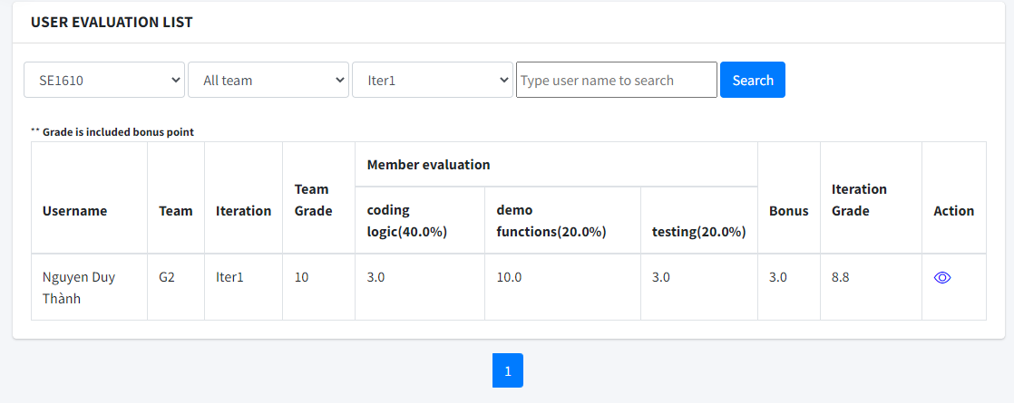

You still can use filter.



You only see your data. Click on  to see details:

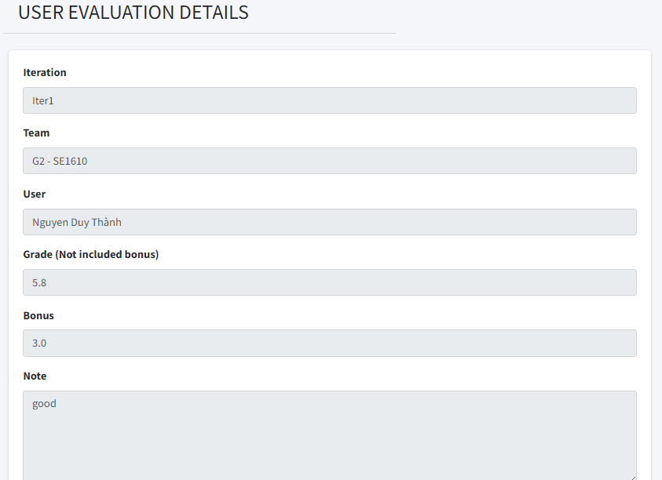

## 5. Student

This workflow is for feature Student and is accessed by roles Student, viewed by Trainer. In this workflow, as a Student, you can perform lots of modified to your own Features, Functions, Issues and Tracking of your project.

To perform action to your:

1. Team’s Feature:

+ Access through link “Feature list” at the drop down list on navigation bar

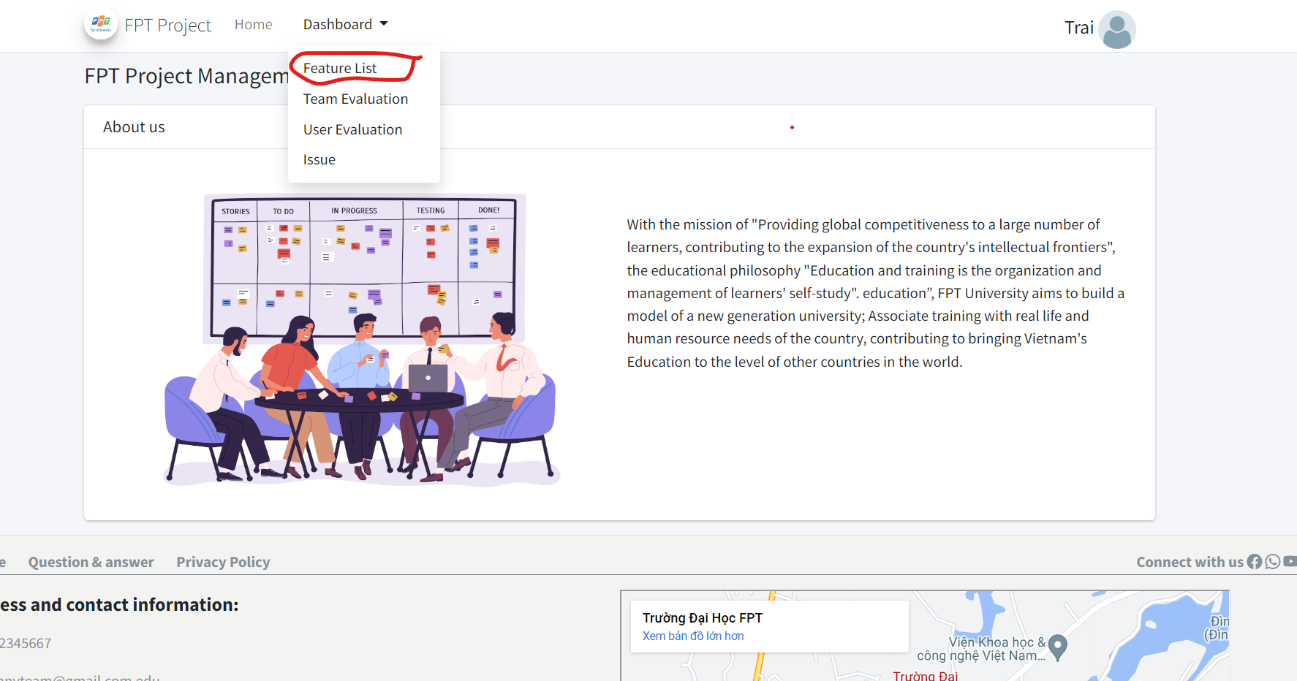

This will direct you into screen Feature list that look something like this:

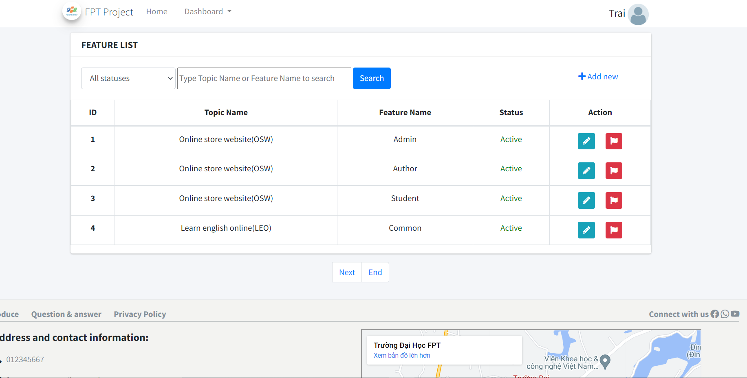

All feature data is showed in the form of table

Allow to filter by feature’s status 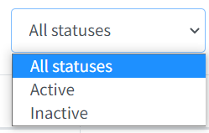 or search by both topic name or Feature name in the search bar.

 Is a button for quick change status of feature. After clicking it and confirm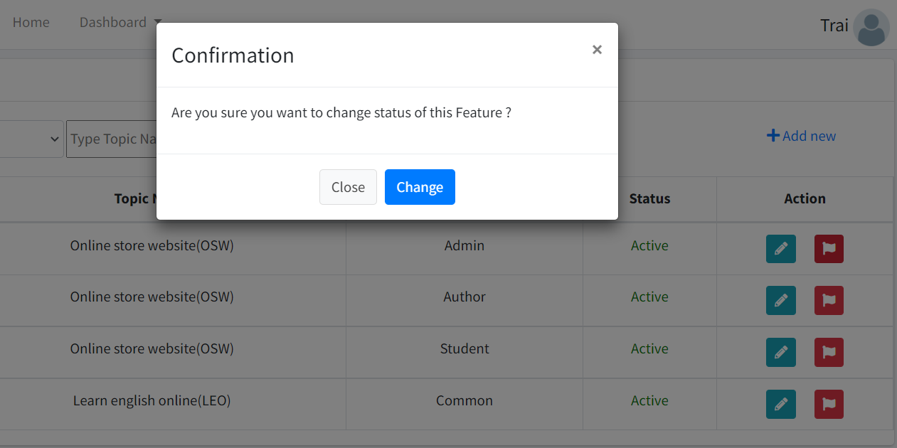

Your feature status will change.

 is for update specific feature. Clicking it will lead to screen feature update where you can see all information of chosen Feature, allow change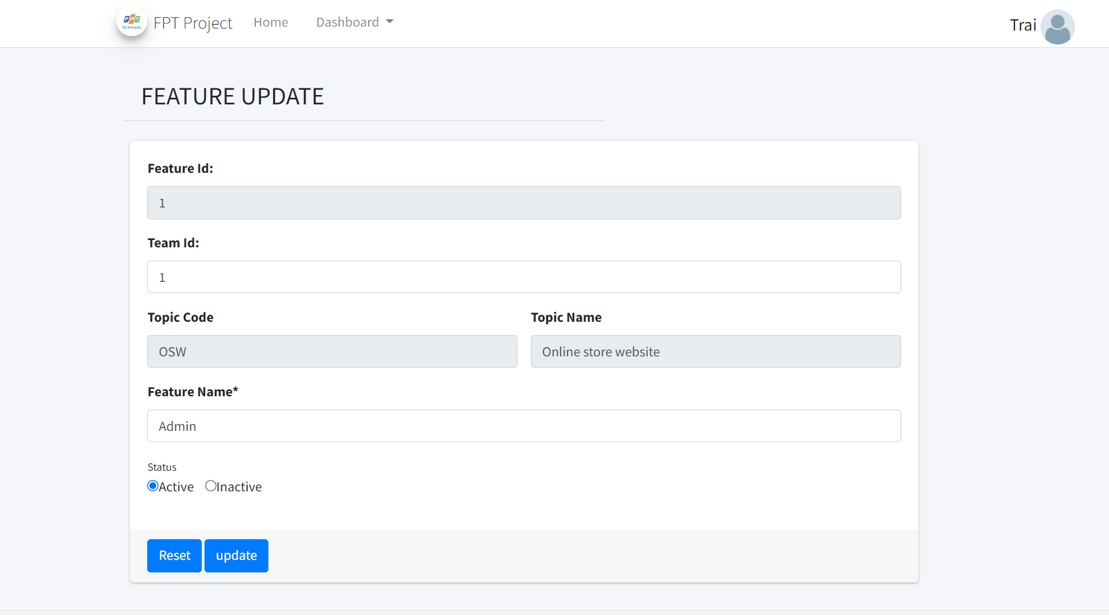

After done changing, click  to update Feature.

 This link open a screen where you can add new Feature with custom info: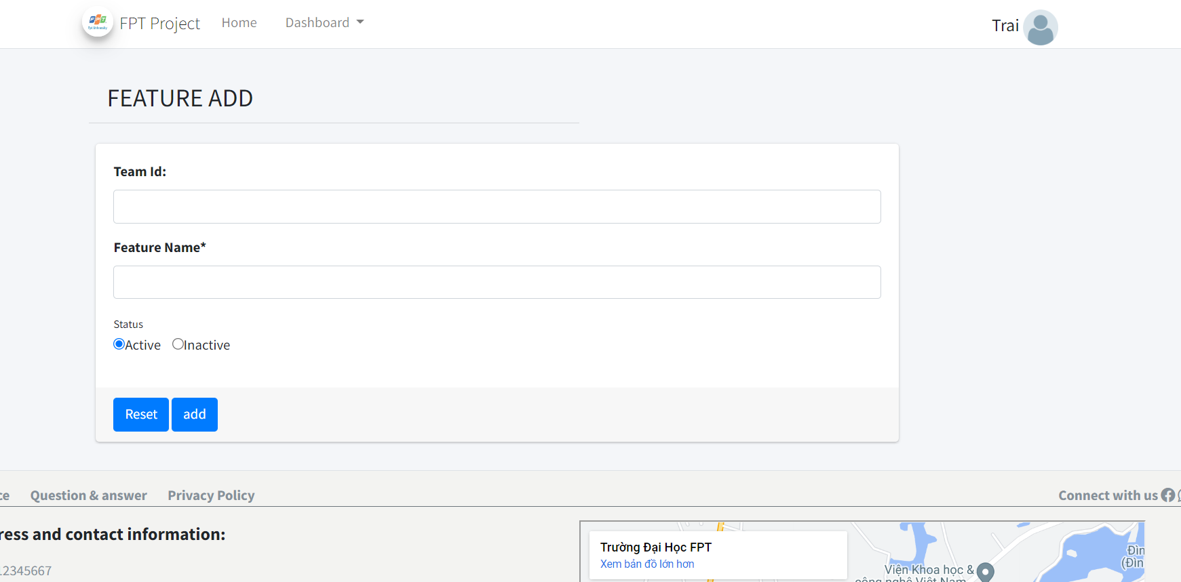

Click add to add new Feature to your team.

1. Team’s Issue:

+ Access through link “Issue” at the drop down list on navigation bar

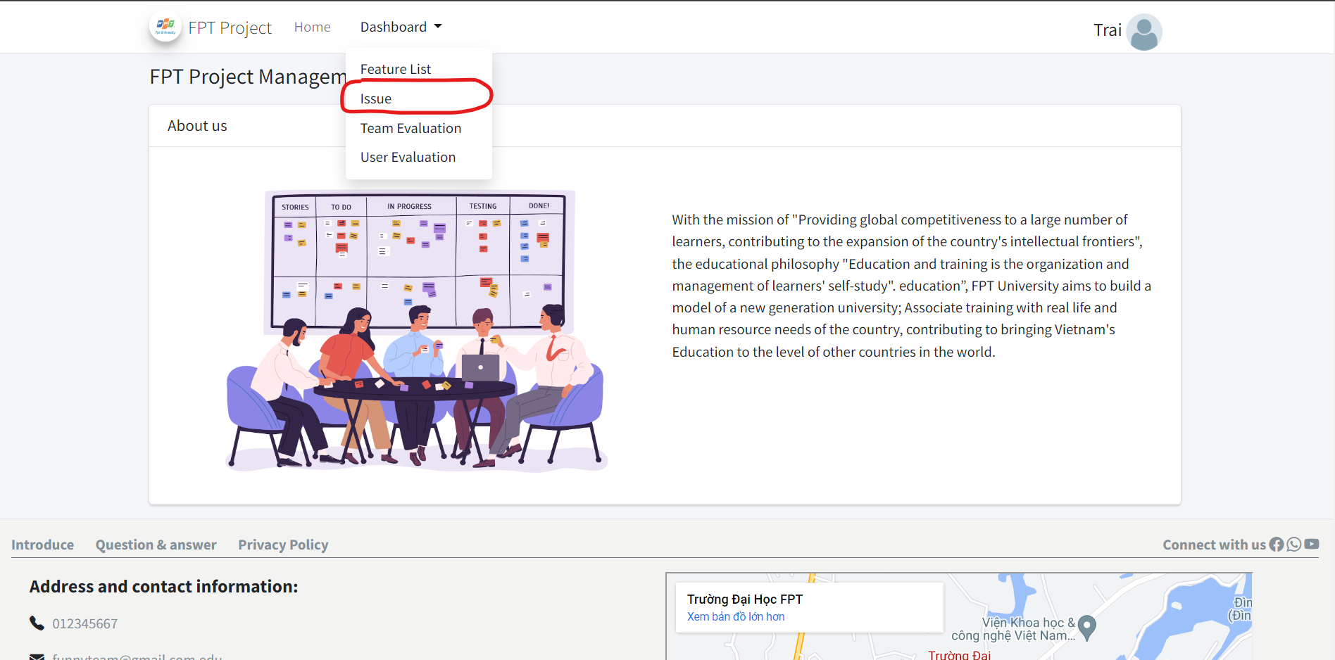

This will direct you into screen Issue list that look something like this:

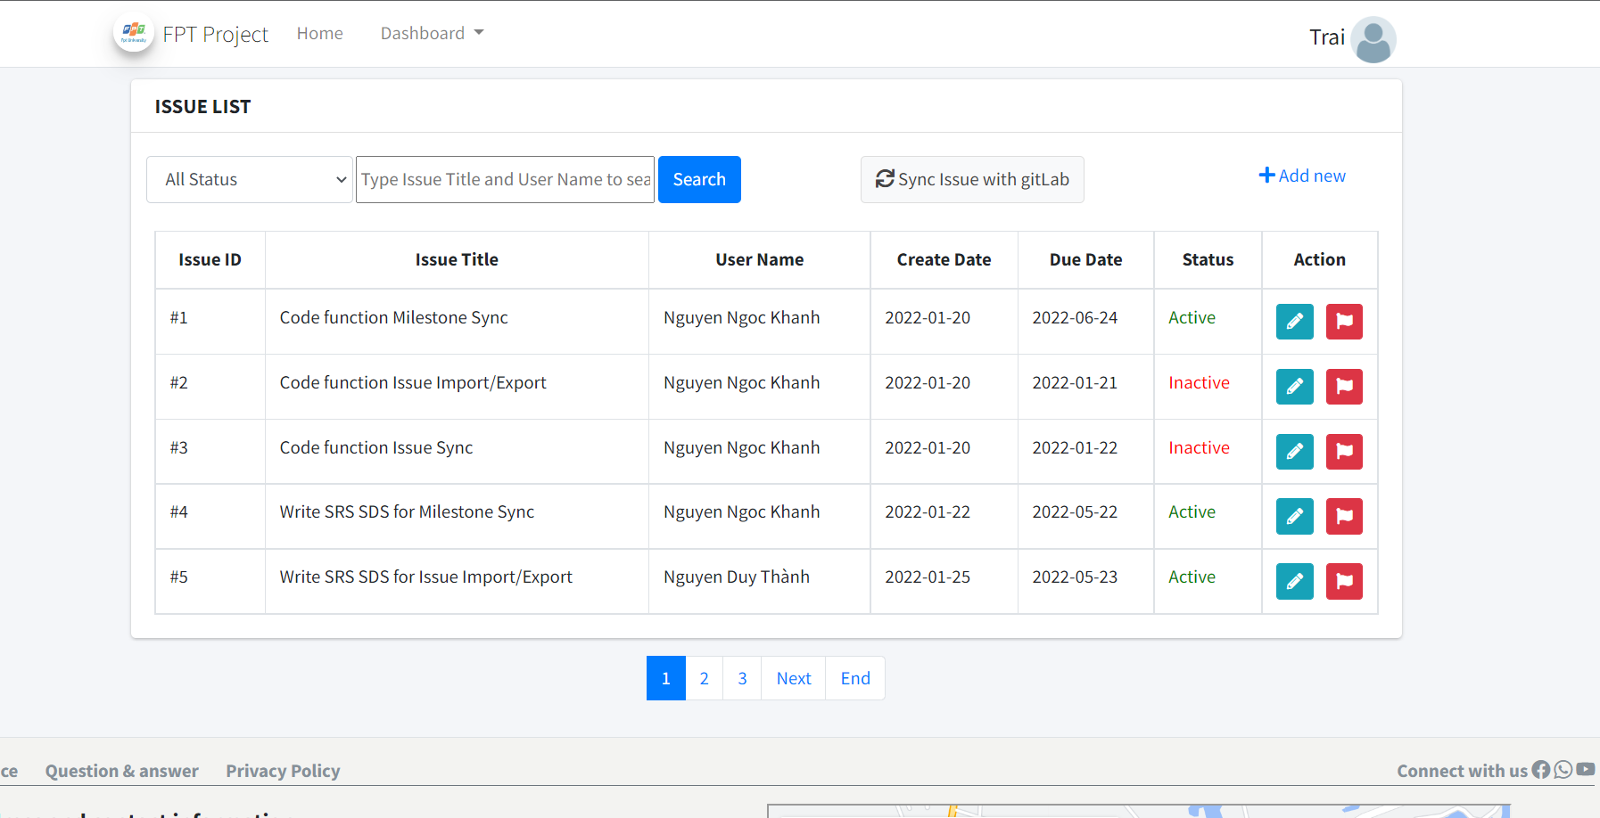

All feature data is showed in the form of table

Allow to filter by feature’s status  or search by both Issue title or User name in the search bar.

 Is a button for quick change status of Issue. After clicking it and confirm

Your feature status will change.

 is for update specific Issue. Clicking it will lead to screen Issue update where you can see all information of chosen Issue, allow change

After done changing, click  to update Issue.

 This link open a screen where you can add new Feature with custom info:

Click add to add new Issue to your team.

If you already have a group that is a subgroup of class’s group on gitlab, you can use Issue sync with gitlab function by clicking on  at Issue list screen, the system will ask you to choose which team to sync:

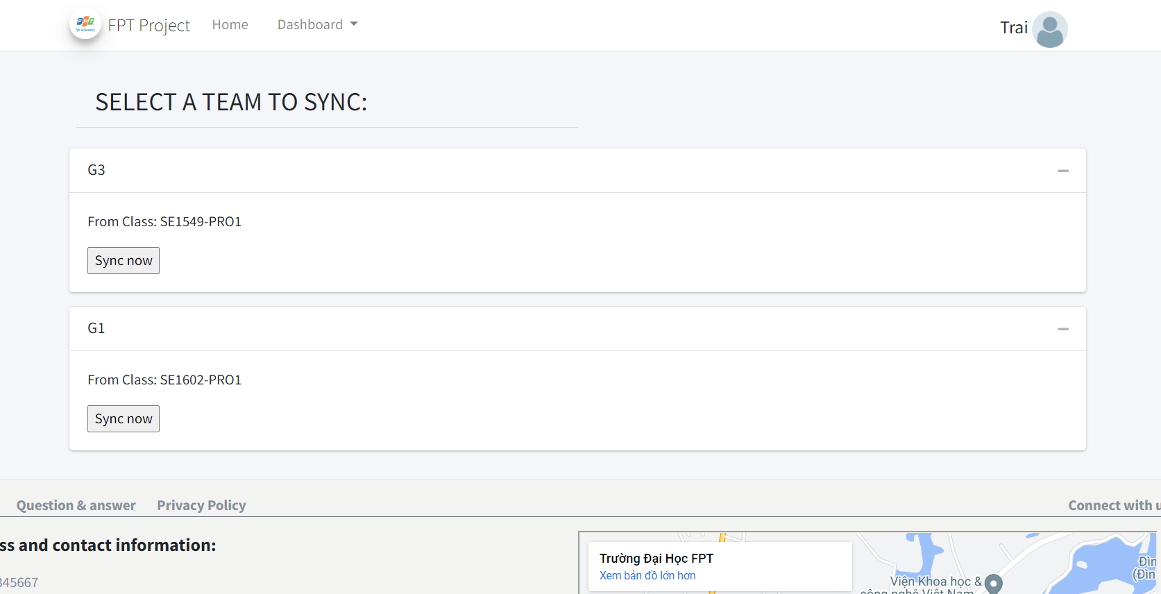

Press  to sync that team’s Issue with gitlab, system prompt 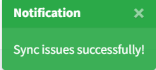

When Sync successfully

1. View Team’s Evaluation:

+)To access Team’s Evaluation, first in home page click “Team Evaluation” in navigation bar.

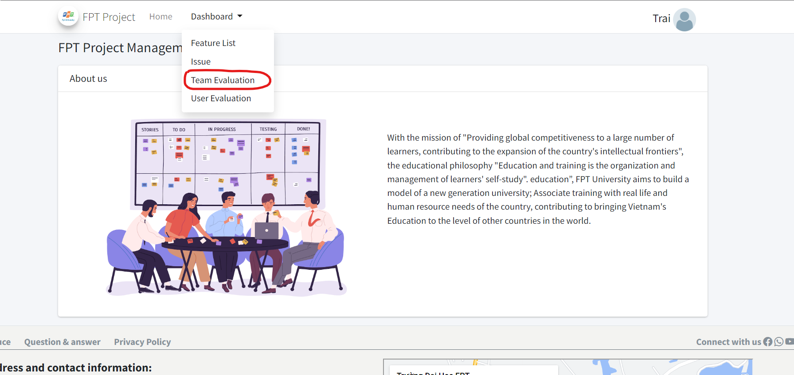

Team Evaluation list look something like this:

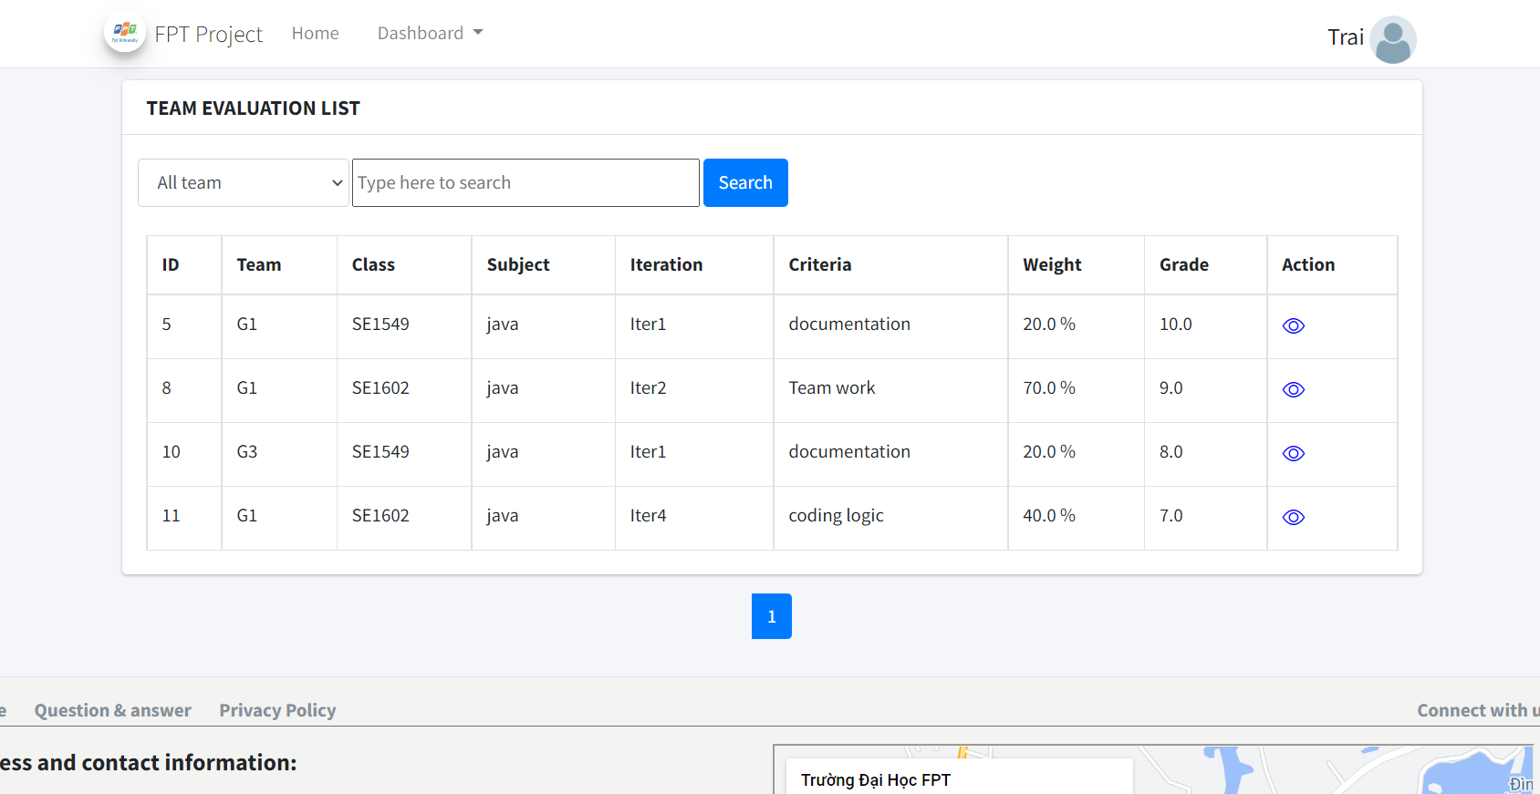

The table only display Evaluation of team where you in. Filter by team

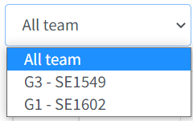

Or search with subject name, iteration name or Criteria at the search bar

Click  to view details of one evaluation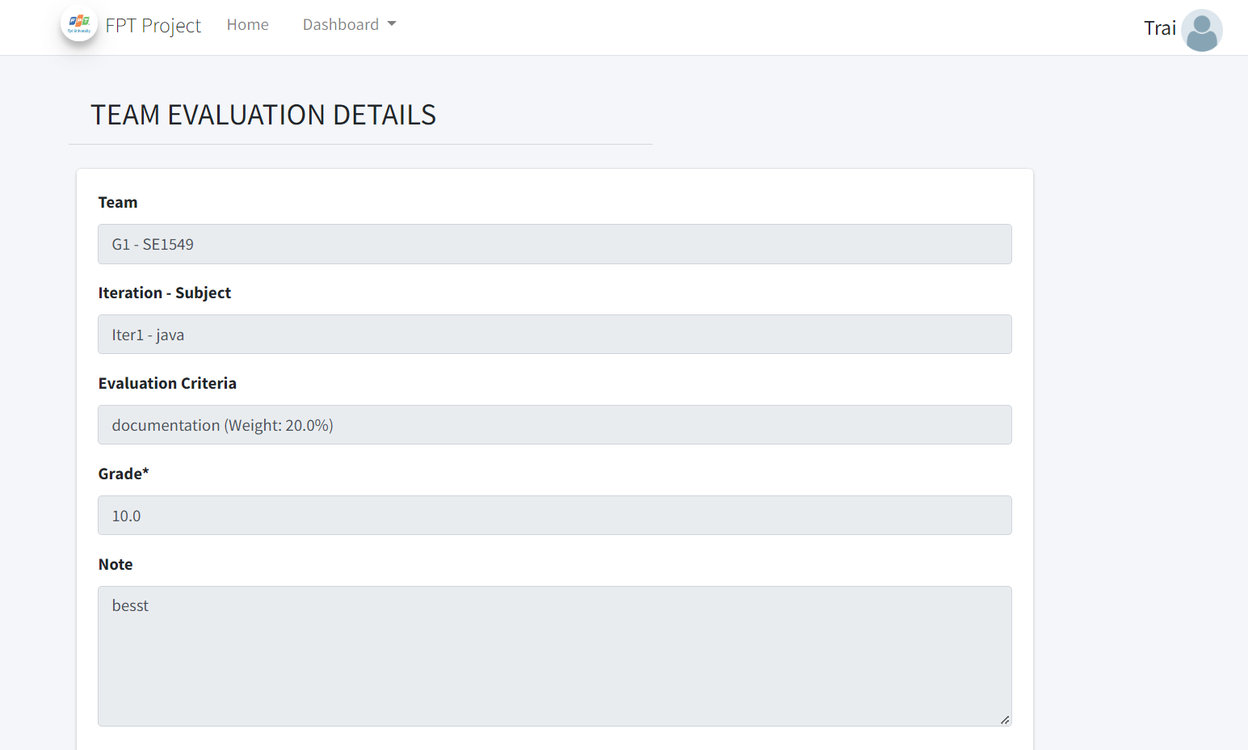

1. User personal Evaluation:

+)To access User Evaluation list, first click User evaluation at the home page: 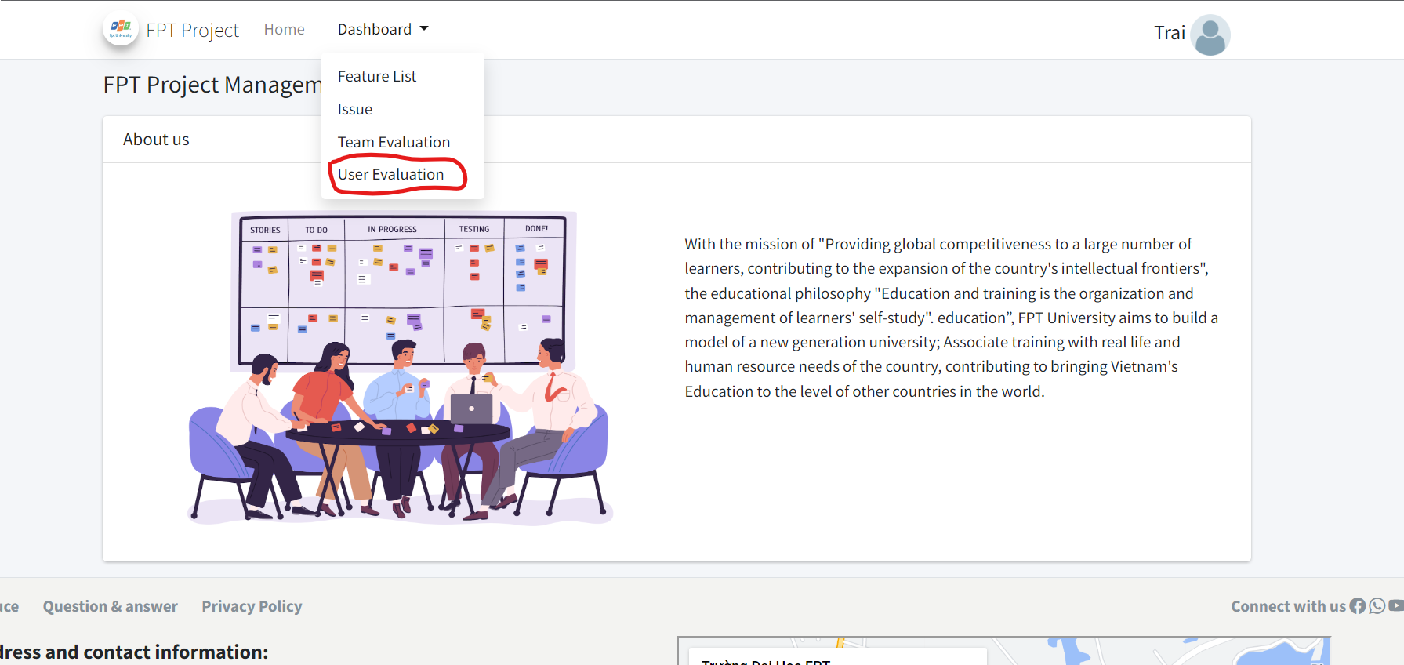

The system will navigate you to a screen where you can only see your own evaluation which graded by your Trainer

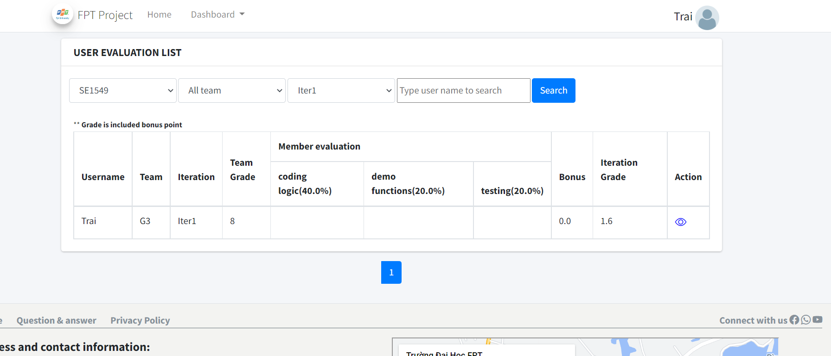

The table allow you to filter by Class 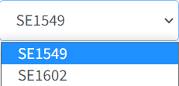 or by Team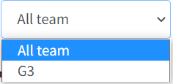

or Iteration 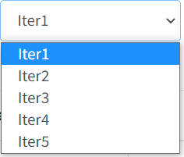

Search by user name in the search bar

Click  to view details of one evaluation

